ROLE PROFILE

Role Title: Support Worker – Complex Services

Service Area: Learning Disability Services – complex services

Directorate: People

Accountable to: Team Leaders or other named manager grade F and above

Grade: D

JE Code – JE0585 Competency Level: 1
JE0585

Purpose of job (outline what, to whom and why)

To support adults who have learning disabilities with complex needs to receive a service which meets their needs in accordance with the ethos of Positive Behaviour Support (PBS).

This will include working as part of a team and having effective communication with families and other stakeholders.

Key Objectives (list what outcomes are essential)

1 | Supporting people to maximise their opportunity for self-expression, communication and personal development.
2 | To deliver a high quality service to people with complex support needs, this may include behaviours of concerns and / or complex health needs, ensuring PBS is central to the delivery of care and support.
3 | To identify and plan meaningful activities with people and support them to access these.
4 | To effectively record information in all formats, this will include contributing to the writing risk of assessments and individual support plans. Use MKC IT systems effectively as well as giving appropriate verbal handover and feedback.
5 | Service users experience continuity of support and relationships wherever this is possible.
6 | Follow instruction from Team Leaders to respond to changes in need including crisis support.
7 | Delivering high quality person centred care and support this will include ensuring identified needs are met in line with individual support plans, training and MKC policies.
8

Scope (outline the size or scope of the role, direct or indirect responsibility for people, finances, resources and any special aspects of the role)

The role holder builds close working relationships with people with a learning disability and complex support needs .

The level of support that the role holder provides to a service user will depend on the individual’s assessed and eligible needs, they will help develop and deliver a programme of activities working within the ethos of Positive Behaviour Support. They will be required to assist people with personal and intimate care, this will include moving and handling.

The role holder will also be expected to work with vulnerable service users in line with MKC policy and procedure. This support can be at a time which suits each service user and includes support outside normal “office” hours. The role holder will be required to work across all complex services, this will include being expected to work in a 24 hour rotational rota providing waking nights and sleep in support.

The role holder works closely with his or her line manager and has regular supervision and appraisal, participates in regular team meetings and undertakes relevant, identified training and coaching.

The role has a direct impact on service users’ well being. While this is paramount, the role holder also facilitates the maintenance of relationships that are important to the service user where this is needed (i.e. with family members, community resources etc.). Where areas of concern become apparent the role holder should report and record these in line with MKC policy i.e. Safeguarding Vulnerable Adults.

The role holder will mostly work as part of a team but this may be in any number of different services/community settings. Driving, escorting or providing other support with transport to access services will be part of the role.

The role is required to follow MKC lone working policy.

The role requires a Disclosure and Barring Service certificate.

Work Profile (outline the main areas of responsibility and accountability and competencies)

Each service user has an agreed plan for their care and support (reviewed regularly) and the role holder uses this plan as the basis for their work with each service user. The role holder participates in identifying priority areas where care and support is required, contributes to working strategies and assists the service user in implementing these. The level of support will differ with the individual needs of each service user, respecting the individual’s dignity.

The role holder acts as a named person within their service area, liaising between a service user and support services that s/he may access within their team. This will include contributing to and enabling service users to participate in their support planning.

The role holder records work undertaken per the care and support plan in line with agreed policy, reports on work completed to relevant people and prepares for planning meetings (i.e. individual review meetings, “professionals” meetings), as well as recording any other relevant information, using a range of manual and electronic recording systems. The role holder also has a responsibility to monitor the ongoing wellbeing of each individual that their service area supports, including noting and reporting significant changes to relevant people within and outside the organisation.

The role holder will support service users to participate fully in the community by supporting a range of valued activities, and promoting real choice as per the support plan.

The role holder will support service users with personal care and health needs which may include assistance with personal hygiene, washing, dressing, eating, drinking and taking of medication ensuring that they follow the policies such as moving and handling, Dysphagia, administration of medication and personal and intimate care.

The role holder will work proactively, responding to the need of the service users to help identify stratergies to minimise behaviours of concern.

The role holder will be expected to identify and report Health and Safety issues concerning buildings, colleagues and service users and respond to reduce risk as required.

Job Context

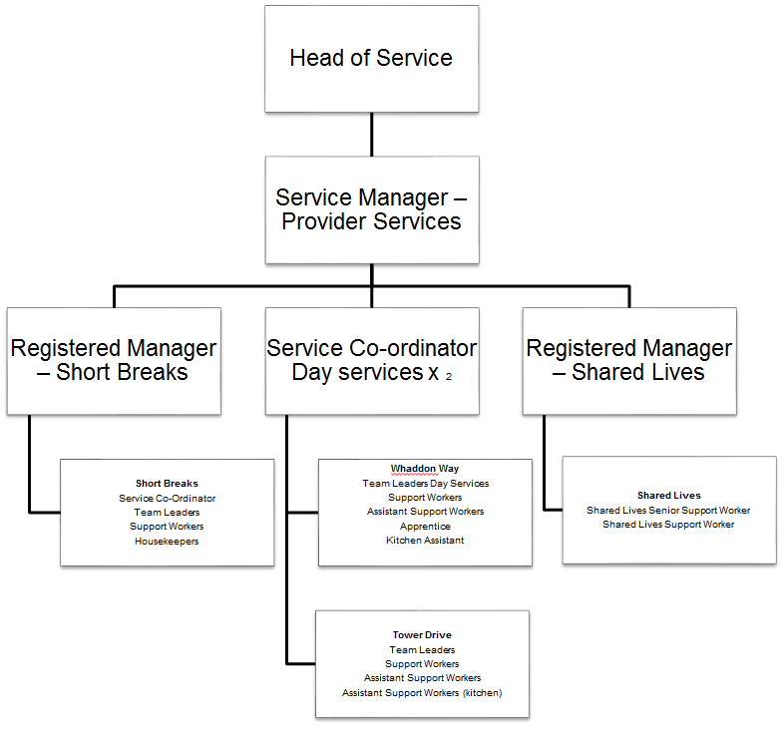

PERSON SPECIFICATION

In this section the Skills, Knowledge, Qualification and Competency requirements to perform the role to a satisfactory standard are set out. The extent, nature and level of the role holder’s knowledge and skills should be specified
Awareness some knowledge or skills sufficient to show aptitude and the ability to learn in the particular work area
Significant knowledge and skills gained through practice and/or qualification sufficient to fulfil the role requirements
Extensive knowledge and skills gained through practice and/ or qualification to fulfil the role requirements and contribute to training others and developing policy and practice in the work area

PERSON SPECIFICATION | Examples specific to role | Required |  | Level |  |  | Method of Assessment interview, testing, reference
PERSON SPECIFICATION | Examples specific to role | Essential | Desirable | Awareness | Significant | Extensive | Method of Assessment interview, testing, reference
SKILLS AND KNOWLEDGE  Technical knowledge and qualifications | Positive relationship building skills  Non – judgemental Listening skills  Understanding the purpose and need for confidentiality.  Flexibility in working practice – time management and approach to service users.  Valuing others –respecting others’ opinions and ideas. Anti-discriminatory attirtuide and practice towards all memebers of society.Ability todevelop meanginful packages of support  Knowledge of related legislation and guidance  Ability to recognise risk and respond to keep people safe  Level 1 literacy skills in line with council’s of Plain English standards  Level 1 numeracy skills  Ability to monitor and report changes in needs ,  Recording and Reporting, Limited decision making (related to task)  Demonstrates an understanding of health and safety issues  Willingness to learn new skills  To have a full manual driving licence as you may need to support service users in company vehicles or your own car (area specific) | ✓✓  ✓  ✓  ✓  ✓  ✓  ✓  ✓  ✓  ✓  ✓  ✓  ✓  ✓ | ✓  ✓ | ✓  ✓ | ✓  ✓  ✓  ✓  ✓  ✓  ✓  ✓  ✓  ✓  ✓  ✓  ✓  ✓ |  | Interview/Working Assessment  Interview Interview/ t  application  Interview  Interview  applic /Interview  Interview  Application/test  Test  applic /Interview  applic ation  /Interview  Application form
Planning and organising work | Ability to understand rotas and procedures and able to work in line with these.  Understanding of the need for reliability and dependability and it’s impact on the service | ✓  ✓ |  |  | ✓  ✓ |  | Applic/interview  Application
Planning capacity and resources | Considering the use of Milton Keynes Council resources and work in a manner which minimises waste | ✓ |  |  | ✓ |  | Interview
Influencing and interpersonal skills | Delivering information clearly,accurately and succinctly to others (Service users, Colleagues, Family Carers)  Challenging inappropriate behaviour and attitudes. | ✓ | ✓ | ✓ | ✓ |  | Application
PROBLEM-SOLVING  Using initiative to overcome problems | Base decision making on the needs and abilities of each person using services  Able to question decisions and check these with Team Leaders |  | ✓  ✓ | ✓  ✓ |  |  | Interview  Interview
Managing risk | Contributing to risk assessments of people using services.  Implementing risk assessments and management plans.  Awareness of health and safety issues for self and service users  Supporting service users in all aspects of their health including minimising infection. | ✓  ✓  ✓ | ✓ | ✓ | ✓  ✓  ✓ |  | Interview  Applica/Interview  Interview
Managing change | Able to work flexibly within a changing environment to develop their practice in line with legislation and guidance. | ✓ |  |  | ✓ |  | Interview
Accountability and flexibility | Able to work as part of a team with support and direction from team Leaders and other team members. | ✓ |  |  | ✓ |  | Application/inter
Managing people | No management responsibility for other staff members.
Managing financial resources | No financial impact on Milton Keynes Council. May have limited role in supporting people using services with their own finances in line with procedures.

COMPETENCIES REQUIRED – All post holders must be able to comply with the Council’s core competency requirements which include Customer focus, communicating and engaging, managing resouces and risk, organising and improving performance, taking responsibility and team player.

SPOKEN ENGLISH FLUENCY DUTY REQUIREMENT - The ability to converse at ease with members of the public and provide advice in accurate spoken English is essential for this post.

Other information
- able to travel to meet service delivery requirements
- available to undertake work outside of normal working hours

Signed Job holder | Signed Line Manager | Signed Service Head/ Assistant Director
Print Job Holder | Print Line Manager | Print Service Head/ Assistant Director | Date

