ROLE PROFILE

Role Title: Political Assistant

Directorate: Law and Governance

Accountable to: Head of Democratic Services, under the day to day supervision of the political group

Grade: G (£30,451 - £34,728)

Date: August 2021

JE code: N/a Competency Level: N/a

Purpose of job
To undertake research and provide administrative support to the designated Political Party

Key Objectives (list what outcomes are essential)
1 | Responsibility for supporting the Group Leader in developing the Group’s strategic direction and development as a cohesive and effective political entity playing its full role within the Council.
2 | To lead, manage and contribute the provision of a high quality political research and intelligence service for councillors in the Group, with personal responsibility for such service to the Leader of that Group
3 | Prepare motions and questions for full Council meetings
4 | To assist members of the Group in ensuring the timely development of Group policy and to attend Council, selected Executive Board meetings, Scrutiny and other meetings, as required, identifying areas for research and policy development
5 | To oversee the Councillor Casework system on behalf of the Group, monitoring and progress-chasing where appropriate.
6 | To manage the day-to-day operation of the Group Office and supervise Group Assistants and the Group Casework system.
7 | To keep abreast of developments within local government and advise the Group accordingly and ensure that Group members are aware of national party policy and emerging policy developments, providing expertise and advice as necessary so the group functions effectively.
8 | To prepare and present material including press releases for the media or community groups from the political group’s perspective
9 | To liaise with the Communications Team as appropriate to maintain contact with the media and to monitor press coverage and advise on the most effective response.
10 | To draw attention of the Group Leader or Group officers issues of a sensitive nature being considered by officers or councillors and/or raised by members of the public.
11 | To help members work with internal and external bodies to ensure policy positions are advanced and agenda items put forward and followed up to advance policy to maximum effect.
12 | To be responsible for arrangements in connection with the delivery of regular reports by members of the group and to provide support as required in their drafting. Develop an information and retrieval service to support an effective and efficient research system.
13 | To liaise and communicate with political Group Members and Council Officers and the political structures within local government representative organisations, other Local Authorities and interested parties (including MPs).
14 | To prepare reports on progress and achievements and areas of weakness and under performance for the group. To support the training and development of councillors within the group to improve individual and group performance.
14 | To be responsible for arranging Group events (e.g. group seminars and meetings) and to contribute to the arrangements for other events (e.g. Cabinet seminars).
15 | To assist with staff and Councillor training and development, including induction of new Councillors.
16 | To research, evaluate and analyse issue which are of interest to the Group and to develop action plans and monitor progress.
17 | To offer support to all group members so as to empower them to carry out their roles as Councillors.

Note

- This is a post under paragraph 6 of schedule 1 of the Local Government Act 2000 including Local Government (Assistants for Political Groups (Remuneration) Order 1995). The work of the Political Assistant must accord with current legislation and/or regulations.

- It is politically restricted under section 2(21) of the Local Government and Housing Act 1989.

Scope (outline the size or scope of the role, direct or indirect responsibility for people, finances, resources and any special aspects of the role)

The post will not have any managerial or budgetary responsibility.

Relationships

The post holder will be accountable to the nominated officer of the Political Group for the performance of tasks included in the job description. For the purposes of administration including conditions of service, the post will report to the Head of Democratic services

The key relationships are with the Leader of the political Group, members of the Group and the Council’s Legal & Democratic Services teams including the Director and Head of Democratic Services, the Communications Team, citizens and representatives of other councils and external organisations. The post holder must exercise tact and discretion at all times in managing these relationships and they must meet or exceed corporate standards of customer care at all times.

Team Management
The post holder will not have any management duties

Confidentiality and Judgement

This role requires the exercise of proper integrity in respect of confidential matters and personal information obtained during the execution of duties.

Prioritisation of Workloads

The post holder will be responsible for prioritising and co-ordinating their workload in accordance with the wishes of the Group Leader

Work Profile (outline the main areas of responsibility and accountability and competencies)

To support the Leader, deputy Leader, Whip and all group members by:

- preparing motions and question for Full council meetings,
- providing policy research and briefings for Councillors use at various meetings of the Council,
- drafting speeches, media releases, comments, articles, social media, preparing councillors for interviews etc,
- preparing agendas for group meetings,
- organise away days and training,
- draft standard responses and support casework queries
- other ad hoc tasks as directed by the Group Leader and Deputy Leader ,
- liaise with key stakeholders including local party organisations, elected members and senior Council officers, and
- liaise with the regional and national party office on issues regarding the Group as required .

Job Context
See attached structure chart
Democratic Services structure – August 2021

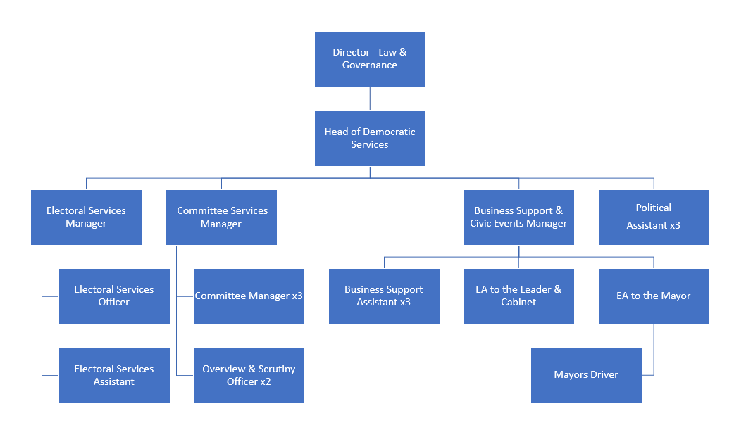

PERSON SPECIFICATION

In this section the Skills, Knowledge, Qualification and Competency requirements to perform the role to a satisfactory standard are set out. The extent, nature and level of the post holder’s knowledge and skills should be specified

Awareness some knowledge or skills sufficient to show aptitude and the ability to learn in the particular work area
Significant knowledge and skills gained through practice and/or qualification sufficient to fulfil the role requirements
Extensive knowledge and skills gained through practice and/ or qualification to fulfil the role requirements and contribute to training others and developing policy and practice in the work area

PERSON SPECIFICATION | Examples specific to role | Required |  | Level |  |  | Method of Assessment application, interview, testing, reference
PERSON SPECIFICATION | Examples specific to role | Essential | Desirable | Awareness | Significant | Extensive
SKILLS AND KNOWLEDGE  Technical knowledge and qualifications and Political Awareness | A detailed understanding of and commitment to the priorities agenda of the political group appointed to. Knowledge of the local political structure and operation. | x |  |  |  | x | Application & Testing
 | Experience of building and sustaining effective working relationships with a variety of stakeholders including elected Councillors and Senior Officers. | x |  |  | x |  | Application, Interview & Testing
 | Experience of undertaking research to support political agendas and contribute effectively to the development of Group policy. |  | x |  | x |  | Interview & Testing
 | Awareness of the sensitivities of working with elected members and the ability to work with tact and diplomacy in a confidential environment. | x |  |  | x |  | Interview & Testing
 | Experience of preparing speeches for major events |  | x |  | x |  | Application & Interview
 | Membership of the political party appointed to support. | x |  |  | x |  | Application & Interview
 | An understanding of the role of the modern councillor and their support needs |  | x |  | x
 | Ability to work effectively under pressure and manage multiple priorities sensitively and diplomatically |  | x |  | x
 | Confidence and ability to command the confidence of senior officers, councillors and external bodies |  | x | x
 | Well-developed communication skills across a range of media including the ability to prepare and present reports on complex issues and to a range of audiences |  | x |  | x
 | Experience of leading and progressing project work |  | x |  | x
 | Ability to maintain strict confidentiality on all matters arising from the political group |  | x |  | x
 | Good IT skills with experience of Microsoft Office and Windows | x |  |  |  | x
ACCOUNTABILITY and RESPONSIBILITY  Undertakes tasks without supervision | Anticipates the needs of the Group and continuously provides excellent service and implements ways to improve efficiency and effectiveness.  Self-motivation with the ability to work under minimal supervision  Willingness to work outside normal working hours from time to time  Willingness to travel to attend meetings and events | x |  |  | x |  | Application & Interview
Personal Development | Able to take responsibility for own performance and development, achieving work objectives and personal and career goals, seeking out development opportunities.  A commitment to continuing professional development | x |  |  | x |  | Application & Interview
Equality & Diversity | Demonstrates awareness, sensitivity and willingness to challenge inappropriate behaviour. | x |  |  | x |  | Application & Interview

COMPETENCIES REQUIRED – All post holders must be able to comply with the Council’s core competency requirements, Customer Focus, Communicating and Engaging, Managing Resources and Risk, Organising and Improving Performance, Taking Responsibility, Team Player, and Excellent Leadership

CORPORATE SAFEGUARDING STATEMENT – All post holders must be committed to applying and upholding the Council’s Corporate Safeguarding Policy Statement. Specific safeguarding responsibilities should be detailed in this document.

Other information
- able to travel to meet service delivery requirements
- available to undertake work outside of normal working hours

