ROLE PROFILE

Role Title: Sheltered Housing Officer

Service Area: Older People’s Housing and Community Support

Directorate: Adult Social Care

Accountable to: Sheltered Housing Manager(s)

Grade: E Competency Level: 2

JE Code: JE0635

Date: August 2021

Purpose of job

To deliver support within the sheltered housing service, working in one or two schemes primarily a to monitoring tenants wellbeing, to help, enable and promote the independence of tenants. To support the wider sheltered housing team by working in other schemes and providing support as required.

Key Objectives (list what outcomes are essential)

1 | To provide a support service to tenants, to promote independent living in accordance with the agreed support plans and the appropriate policies and procedures
2 | To oversee the scheme and the surrounding environment to ensure that it complies with Health and Safety standards and that tenants are kept safe. This includes completing risk assessments and maintaining electronic records
3 | To be responsible for ensuring clear, accurate and concise records are kept in relation to the setting up and managing of tenancies and voids and passed to relevant persons and agencies, using agreed procedures.
4 | To be available to cover in other schemes and to maintain the standards to ensure a quality service across the whole Sheltered Housing service.
5 | To understand the role of assistive technology and to carry out regular testing of all systems and equipment in the schemes. . To act as a facilitator to make referrals to other services on behalf of tenants to ensure their health and well-being.
6 | To establish contacts and activities for the schemes to include and interact with the local community

Scope

The role operates principally within Sheltered Housing to allow tenants to live as independently as possible. The relationship between the Sheltered Housing Officer and the tenants is based on maintaining and encouraging independence

To meet the varied and increasingly complex needs of older people living in Sheltered Housing. To provide each tenant with a week day visit, in a safe and friendly environment working in partnership with other agencies e.g. Domiciliary care services, Occupational Therapists to ensure the wellbeing of tenants

Constructive communication with Health and Social Care Agencies, Housing and Voluntary organisations is vital in securing the objective of the tenant remaining independent.

There is a responsibility for monitoring the physical assets and resources of the building and reporting as necessary, following the agreed protocol. To work closely in partnership with the council’s repairs contractors

The role holder will be supported by the Sheltered Housing Managers and will be expected to participate in 1;1 meetings, team meetings and attend training, some of which is mandatory.

To promote, prepare and organise the use of the guest room, and to inform tenants how to make arrangements for the payment. ,

Work Profile

This is a key role demanding a high standard of support to enable tenants to live independently. It requires significant knowledge of the needs associated with older people, disabled people and other vulnerable groups; taking account of the diverse cultural requirements is also an essential element of the role. It involves mainly working alone but supported by a team structure to meet the tenants assessed needs and responding to any changes or emergency situations as they arise.

There is individual responsibility, with agreement from the tenant, to keep the family, Sheltered Housing Manager and other agencies’ informed and updated of any changes.

The role holder will assess the support needs of the tenant and implement actions to meet agreed outcomes, including maintaining support and independence plans

The role holder is responsible for recording and maintaining accurate records in accordance with agreed policies.

The role holder will take responsibility for their self and the environment to ensure that risks are minimised and have a responsibility to Report potential risks, hazards and incidents.

As a Sheltered Housing Officer you will be meeting the Customer Care Standards for the council and always treating everyone with respect and dignity and being helpful , professional and friendly.

Job Context – Sheltered Housing

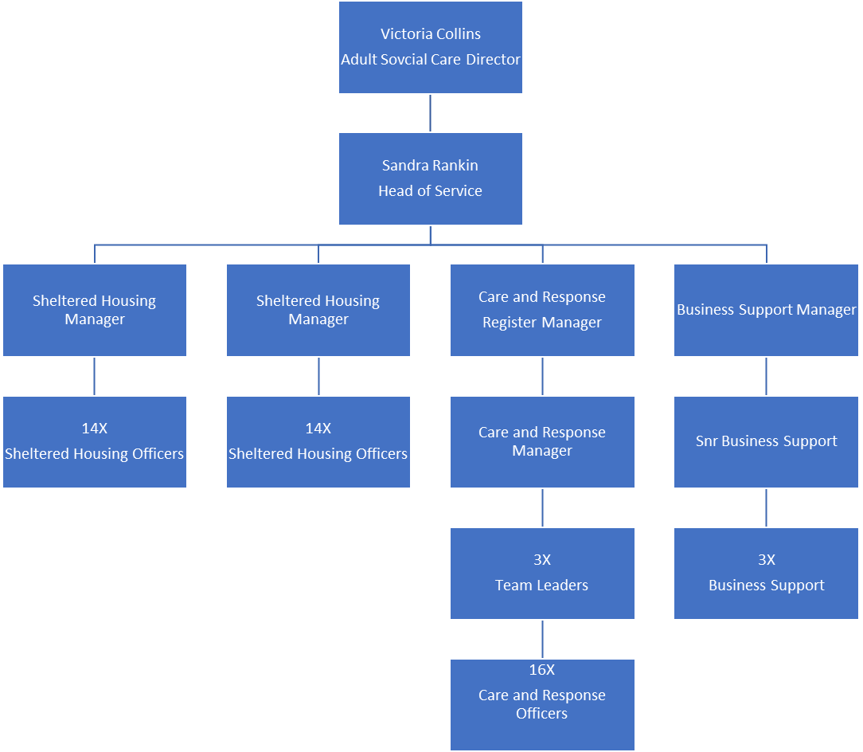

PERSON SPECIFICATION

In this section the Skills, Knowledge, Qualification and Competency requirements to perform the role to a satisfactory standard are set out. The extent, nature and level of the role holder’s knowledge and skills should be specified
Awareness some knowledge or skills sufficient to show aptitude and the ability to learn in the particular work area
Significant knowledge and skills gained through practice and/or qualification sufficient to fulfil the role requirements
Extensive knowledge and skills gained through practice and/ or qualification to fulfil the role requirements and contribute to training others and developing policy and practice in the work area

PERSON SPECIFICATION | Examples specific to role | Required |  | Level |  |  | Method of Assessment interview, testing, reference
PERSON SPECIFICATION | Examples specific to role | Essential | Desirable | Awareness | Significant | Extensive | Method of Assessment interview, testing, reference
SKILLS AND KNOWLEDGE  Technical knowledge and qualifications | - Good level of education including 5 GCSE’s or equivalent |  | ✓ |  |  |  | Application form
SKILLS AND KNOWLEDGE  Technical knowledge and qualifications | - Professional Qualification Certificate in Supported / Sheltered Housing/NVQ |  | ✓ |  |  |  | Application form
SKILLS AND KNOWLEDGE  Technical knowledge and qualifications | - Requirement to undertake mandatory training to fulfil regulatory standards | ✓ |  |  |  |  | Interview
Planning and organising work | - Taking responsibility for delivering own work and meeting agreed work objectives. Working to agreed guidelines.  - Able to work alone or as part of a team. Prioritising work loads in accordance with the needs of the service. | ✓  ✓ |  | ✓ | ✓ |  | Reference/interview  Reference/interview
Planning capacity and resources | - To ensure the workload is completed within the given timescales. | ✓ |  |  | ✓ |  | Interview
Planning capacity and resources | - Report any deficiencies in physical assets or resources and Health and Safety issues. | ✓ |  |  | ✓ |  | Interview
Planning capacity and resources | - Being part of a team and supporting the service to achieve its work goals. | ✓ |  |  | ✓ |  | Interview and references
Influencing and interpersonal skills | - Able to build effective and ethical relationships by the use of excellent communication skills. | ✓ |  |  | ✓ |  | Interview and application form
Influencing and interpersonal skills | - Clear written, verbal and I.T. skills with social and observational awareness. | ✓ |  |  | ✓ |  | Interview and application form
PROBLEM-SOLVING  Using initiative to overcome problems | - Providing suggestions and feedback on working methods to improve performance. |  | ✓ | ✓ |  |  | Interview and references
PROBLEM-SOLVING  Using initiative to overcome problems | - Being open to ideas on how to improve the current methods and levels of service. | ✓ |  | ✓ |  |  | Interview and references
PROBLEM-SOLVING  Using initiative to overcome problems | - Taking responsibility to minimise issues that could disrupt work, and escalate the issue where appropriate. | ✓ |  |  | ✓ |  | Interview and references
PROBLEM-SOLVING  Using initiative to overcome problems | - Ensuring that when a service user has a problem, we do our best to put it right first time. | ✓ |  |  | ✓ |  | Interview and references
Managing risk | - Taking responsibility for self and environment to ensure that risks are minimised. Reporting potential risks, hazards and incidents. | ✓ |  |  | ✓ |  | Interview
Managing risk | - Take responsibilities for Risk Assessments | ✓ |  |  | ✓ |  | Interview
Managing change | - Consulting with tenants to ensure that we are providing support to the required standards. | ✓ |  |  | ✓ |  | Interview
Managing change | - Being receptive to change and keeping service users involved in changes that may affect them. | ✓ |  |  | ✓ |  | Interview
Managing change | - Balancing different service user needs and expectations | ✓ |  |  | ✓ |  | Interview
ACCOUNTABILITY and RESPONSIBILITY  Undertakes tasks without supervision | - Taking responsibility for delivering own work and meeting agreed work objectives | ✓ |  |  | ✓ |  | Interview and references
 | - Acting in line with the council’s policy and legislation which states that people must be treated respectfully and confidentially | ✓ |  | ✓ |  |  | Interview and references
 | - Making sure that all service users have fair and equal access to services. | ✓ |  | ✓ |  |  | Interview and references
Managing people | - Demonstrating that work is contributing to the overall aims of the Council, directorate, department and team | ✓ |  | ✓ |  |  | Interview
Managing people | - Effectively handling inappropriate behaviour to ourselves and others. | ✓ |  |  | ✓ |  | Interview
Managing financial resources | - Using resources efficiently and effectively and in line with the Council’s environmental responsibilities and best value guidelines. | ✓ |  |  | ✓ |  | Interview

Role Activities

Example do activities in the role
1 | Promoting and enabling tenants to participate and run social activities, attend meetings and forums within the scheme and wider community.
2 | To ensure the cleaning contract is carried out in line with the specification, completing the relevant monitoring information.
3 | In an emergency situation to undertake the collection of prescriptions, shopping and the preparation of snacks, and to respond to emergencies that may require the need to communicate with emergency services, undertakers or the coroners court.
4 | To carry out these duties in any scheme under the direction of the Sheltered Housing Manager.
5 | To organise the use of the Guest Room under the agreed procedure.

COMPETENCIES REQUIRED – All post holders must be able to comply with the Council’s core competency requirements which include communication, respect for others, customer service, drive for results, delivering the promise and continuous personal development.

SPOKEN ENGLISH FLUENCY DUTY REQUIREMENT - The ability to converse at ease with members of the public and provide advice in accurate spoken English is essential for this post.

In addition for those posts with management responsibilities the competencies will include managing self and personal skills, providing direction, facilitating and managing change, working with people, using resources, achieving results, promoting policy, values and culture, customer service and health and safety.

Other information
- able to travel to meet service delivery requirements
- available to undertake work outside of normal working hours

Signed Job holder | Signed Line Manager | Signed Assistant Director
Print Job holder | Print Line Manager | Print Assistant Director | Date

