ROLE PROFILE

Job Title | Independent Chair
Directorate | Children Social Care
Section | Safeguarding and Quality
Accountable to | Head of Safeguarding and Quality
Grade | K
JE Code: | JE1760 | Competency Level: 3

Purpose of Role

The Safeguarding Team sits within Children Social Care and incorporates specialist statutory child protection and child care reviewing services. Child Protection Coordinators have management responsibility for specific processes relating to Child Protection Conference processes. Independent Reviewing Officers manage the statutory Child Care Reviewing process in relation to each Looked After Child. Role holders in the Safeguarding Team have a lead responsibility for specific assigned areas of practice, such as the development and implementation of Quality Assurance processes across Children & Families; in promoting and scrutinising practice and outcomes for children; and in fulfilling the Council’s statutory requirements under the Children Act 1989 and other relevant legislation.

Key Objectives (list what outcomes are essential)

1 | The Local Authority is compliant with the responsibilities and functions laid out in relevant legislation and national and local policy and guidance relating to child protection including management of allegations. The IC acts on behalf of the council to manage child protection and looked after children processes, to ensure that all children in Milton Keynes are safeguarded.
2 | The IC establishes and implements child protection and looked after children policy and practice in compliance with legislation, guidance and internal policies and procedures and leads on specialist aspects of the safeguarding process on behalf of the LA and MK Together, supported by robust evidence-based decision making and planning.
3 | The IC operates a professional consultation service, providing advice and information to staff within MKC, partner agencies and external organisations regarding child protection and looked after children processes and other specialist aspects of the child protection process.
4 | The child’s voice is heard; the children and family are appropriately participant in the child protection and looked after children process resulting in the children being able to achieve good outcomes.
5 | The IC models and promotes partnership with key agencies, ensuring collaboration, information sharing and integrated planning for the benefit of the children.
6 | Robust quality assurance and scrutiny systems are in place and reported within Children Social Care, which demonstrably make a difference to professional practice and outcomes for children and families in Milton Keynes.
8 | Role holders lead and contribute to activities requiring expert knowledge and specialist skills such as training and development, policies and procedures, projects and other tasks relating to child protection and children in care, on behalf of Children Social Care and partner agencies.
9 | Routine cover for the LADO as part of the duty system

Scope

The Safeguarding Team provides independent off-line specialist consultation and statutory services in respect of children in care and child protection.

The role holder reports to the Head of Safeguarding and is statutorily responsible for a case load of named children subject to child protection plans and/or children in the care of the Local Authority and all associated processes.
In Milton Keynes, the roles of Child Protection Coordinator and Independent Reviewing Officer are combined into the role of Independent Chair; post holders are routinely be required to cover LADO responsibilities, plus other specialist statutory roles within the Safeguarding Team according to need. The post holder also represents and carries out delegated tasks on behalf of the Head of Safeguarding, such as Quality Assurance, data and performance, service development and delivery, representation on groups and forums and supervision and support of other staff.

These role holders perform statutory functions in areas of regulated and highly scrutinised activity. They need to work effectively with a range of partners and at all levels to inform, influence and challenge policy and practice and to contribute to integrated planning and delivery of optimal outcomes for all children in Milton Keynes.

The post holder will undertake a key Quality Assurance function for the LA, leading the development of strategic, resource, policy and practice improvements and highlighting areas of concern.

People

Children’s Social Care operates within an interagency framework, engaging with service providers within the council and with external agencies and organisations. The post holder provides a specialist lead in the safeguarding children arena and will actively engage with, advise and influence a range of professionals at strategic and operational levels within agencies including police, legal services, health services, schools, third sector and colleagues in operational services in order to deliver good outcomes for children. The post holder will work closely with colleagues across Children Social Care, to contribute to integrated planning and service delivery for all children in MK. This may include providing supervision, consultation, training and development, allocation of work, quality assurance and providing direction.

Direct contact with service users and making decisions which affect their lives is integral to the role. The role involves working with highly confidential and sensitive information and ensuring the voice of the child is central to the development and provision of child protection conferencing and reviewing processes services.

Financial

The role does not involve budget-holding but requires the role holder to focus on the identified needs of children and young people whilst advising, planning and prioritising in the context of ensuring the best use of available physical and financial resources.

Non financial
These post holders demonstrate leadership in a complex organisational environment. They oversee the statutory activities around scrutiny and monitoring of the LA function and performance in terms of care planning and risk management for children. This includes analysis and reporting on relevant data on behalf of Children’s Social Care in respect of the service area responsibilities, and the development and review of policy and procedure. The post holder will contribute to service planning and the management and deployment of the team’s budget and resources.

Special Factors

The post holder will be a highly experienced management-level qualified social worker and will use their specialist and extensive knowledge to raise the profile of safeguarding services, acting as an ambassador for Children’s Services and champion for children.

WORK PROFILE

The role holder is responsible for the operational management of the Independent Reviewing Service for children in care and the Child Protection Conference Service, as designated by the Head of Safeguarding.

The role holder fulfils the statutory functions of the LA in relation to the independent chairing and management of Child Protection Conferences AND Looked After Children reviews, ensuring that the LA intervention is timely, appropriate, effective and in the child’s best interests. Also where required to cover the LADO functions. The role holder is responsible for associated processes including oversight of the process; direct contact with the child, family, carers and professionals; recording and reporting. The role holder will ensure that decision making is evidence- based and takes into account the needs and views of the child.

The role holder will chair a range of complex meetings including Strategy Meetings and Complex Abuse and manage and advise on associated processes. The post holder is responsible for the scrutinising and advising on the management of risk associated with children’s plans.

The Safeguarding Team has lead responsibility for the development and implementation of the Quality Assurance (QA) Framework and process on behalf of Children's Social Care. The role holder will undertake key QA functions, making a significant contribution to strategic, resource, policy and practice developments and highlighting areas of risk and concern. They will work with the Safeguarding Improvement Officer to ensure that QA is effectively implemented and regularly reviewed in response to national and local developments and lessons learned, so that it remains relevant, up-to-date and accessible. The role holder will lead and participate in a robust programme of qualitative and quantitative audits and other QA activities including user feedback, providing regular analytical reports to the CSC performance management team and others as required. They will scrutinise all aspects of case work and planning to ensure these are conducted in line with agreed national and local standards and that performance targets are met, including full electronic recording of work on ICS. They will provide operational managers with timely information to support them to effectively manage and supervise their staff teams and address issues of risk management, care planning and/or practice as and when appropriate.

Additional responsibilities

- To monitor, analyse and report on relevant information and data and manage work to ensure that objectives and performance targets within safeguarding services are delivered and improved.

- To use specialist knowledge and skills to proactively identify gaps and areas for improvement in practice, policy and procedure related to Council and inter-agency safeguarding and to lead initiatives to address areas for development.

- To be a member of, lead and advise appropriate work groups, Safeguarding Children Board Sub-Groups, panels and project groups, as required and contribute to the strategic and service delivery developments.

- To investigate complaints and disciplinary matters in accordance with corporate procedures.

- To chair Disruption Meetings and make recommendations in relation to lesson learnt.
- To proactively identify need and develop, lead or contribute to training and awareness raising for Children’s Social Care, wider C&F and other agencies on child care and child protection matters.

- To undertake scrutiny visits (Regulation 33) to children’s residential homes on behalf of the responsible authority as required.

- The post holder may from time to time undertake other duties within the Safeguarding service to support capacity issues within the service commensurate within the level of the post.

Specific responsibilities: The Child Protection Coordinator role

The role holder is responsible for LA function and performance in relation to the Child Protection Conference process, ensuring that all children in need of protection are safeguarded and their well-being is promoted effectively, in line with national legislation and policy. This includes:

- Managing and chairing Initial and Review Child Protection Conferences, ensuring that children are made subject to Child Protection Plans, or that these plans are discontinued, as appropriate and that decision-making is based upon evidence and analysis;
- Operating a consultation service providing advice, guidance and information to staff regarding specialist aspects of the child protection process including risk management.
- Ensuring that the child’s voice is at the centre of care planning and that children and families are fully participant in the child protection process.
- Monitoring casework and decision making to ensure high quality child protection plans are implemented and that the child’s interests are protected throughout the family support and care planning process.
- Offering support and challenge to operational social work staff and managers as appropriate;
- Scrutinising and ensuring the quality of risk management and that social work practice is delivered in accordance with statutory requirements, reporting to the Senior Management Team as appropriate.
- Supporting the LA function and performance in relation to the management of allegations against staff and volunteers.
- Providing specialist training, advice, information and guidance to internal and external colleagues including a range of voluntary organisations.

The post holder will ensure that agreed regular quality assurance functions are undertaken and participate in audits of work on a regular basis.

Specific responsibilities: The IRO role

The IRO leads on the monitoring of the Council’s Corporate Parenting function and performance. The role holder is statutorily responsible for monitoring the function and performance of the Local Authority in relation to planning for children in care, ensuring they are safeguarded and their well-being is promoted effectively in line with national legislation and local policy. The IRO ensures that high quality care plans are implemented and that the child’s interests are protected throughout the care planning process. The post holder is responsible for the statutory duty of the IRO in relation to each Looked After Child for whom they are the nominated IRO, undertaking regular statutory reviewing of care planning for looked after children. This includes:

- Organising and chairing Child Care Reviews and ensuring that there are robust care plans in place for children in care.
- Exercising effective independent oversight of the child’s case and ensuring that the child’s voice is at the centre of care planning and the children & family are fully participant in the care planning process.
- Offering support and challenge to operational social work staff as appropriate
- Consulting with the child in relation to the care plan at each review and at any time that there is a significant change
- Ensuring that the LA is consulting with the IRO in all areas of care planning
- Where the LA is failing to comply with the regulations or is in breach of its duties to the child, then to take the necessary action within the Dispute Protocol and to make a referral to CAFCASS where necessary
- Ensuring that care planning and reviews are conducted in line with agreed national standards and to ensure that local performance targets are met and conform to the required professional and performance standards, including full electronic recording of work.
- Working in partnership with key agencies, ensuring collaboration and information sharing for the benefit of the child to enable high quality care plans are implemented.
- Liaising with national and regional IRO networks to facilitate consistency and improvement.

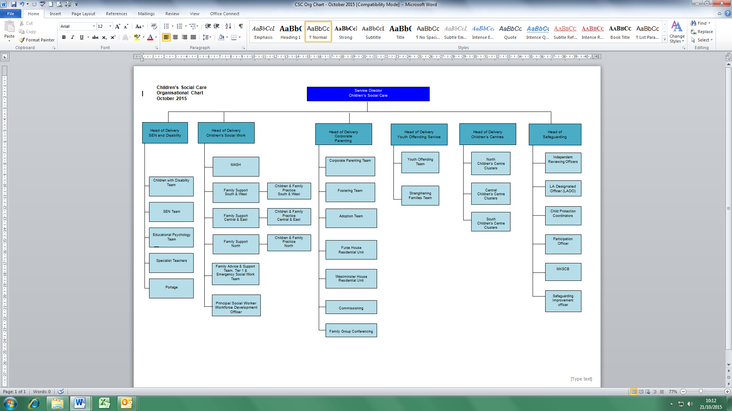

PERSON SPECIFICATION

In this section the Skills, Knowledge, Qualification and Competency requirements to perform the role to a satisfactory standard are set out. The extent, nature and level of the role holder’s knowledge and skills should be specified

Awareness some knowledge or skills sufficient to show aptitude and the ability to learn in the particular work area
Significant knowledge and skills gained through practice and/or qualification sufficient to fulfill the role requirements
Extensive knowledge and skills gained through practice and/ or qualification to fulfill the role requirements and contribute to training others and developing policy and practice in the work area

PERSON SPECIFICATION | Examples specific to role | Required |  | Level |  |  | Method of Assessment interview, testing, reference
PERSON SPECIFICATION | Examples specific to role | Essential | Desirable | Awareness | Significant | Extensive | Method of Assessment interview, testing, reference
SKILLS AND KNOWLEDGE  Technical knowledge and qualifications | Social work qualification (DipSW, CQSW, Degree in social work or equivalent). Registered with the GSCC and meets the needs of ongoing registration  Management qualification or equivalent  Post qualification award in subjects related to child or family work  Significant childcare experience post qualification undertaken in a statutory setting, sufficient to demonstrate a thorough working understanding of the Children’s Social Care agenda.  Specialist and extensive theoretical, practical and procedural knowledge of safeguarding and child care issues, legislation and policy and research  Evidence of ability to interpret and analyse statistical data and management information and to present evaluative reports | X  X  X  X | X  X |  |  | X  X  X  X | Interview and application form
Planning and organising work | Ability to chair complex meetings, analyse, summarise and write/ record relevant information clearly and concisely so that it is easily understood by users and colleagues  Evidence of excellent verbal and written communication skills including communication with children & young people and their families and professionals at a range of levels  Experience of developing policy and procedure | X  X | X |  | X | X  X | Interview, Application, Test
Planning capacity and resources | Evidence of ability to effectively manage workload to ensure effective performance and outcomes  Demonstrated understanding of and ability to monitor performance by the LA of their functions in relation to a child’s case, ensuring that agreed plans are implemented within available resources in a timely and effective manner to achieve best outcomes for the child. | X  X |  |  | X | X | Interview, Application
Influencing and interpersonal skills | Demonstrable high level of interpersonal skills  .  Ability to develop and sustain partnership with other professionals and agencies through trust and credibility  Strong negotiation skills and personal authority: ability to constructively challenge practice and performance where necessary  Proven success in developing and delivering training and awareness-raising activities  Ability to use political judgement and sensitivity  Demonstrates a strong commitment to the promotion of equality  Able to chair complex inter agency meetings | X  X  X  X  X | X  X | X | X  X | X  X  X  X | Interview, Application
PROBLEM-SOLVING  Using initiative to overcome problems | Able to analyse complex information and make decisions including in high risk situations  Ability to question, challenge, solve problems and complete tasks  Assessment skills – ability to demonstrate understanding of process and evidence of ability to apply skills | X  X  X |  |  |  | X  X  X
Managing risk | Able to make considered evidence-based decisions , analyse and evaluate complex information in high risk situations | X |  |  |  | X | Interview, Application,
Managing change | Able to influence and motivate CSC and inter-agency staff to deliver changes in practice, in line with local and national requirements | X |  |  | X |  | Interview, Application
ACCOUNTABILITY and RESPONSIBILITY  Undertakes tasks without supervision | Self-motivating and able to work autonomously using wide discretion and initiative to make difficult decisions and support colleagues in complex work  Able to drive forward improvements in Safeguarding service functions to ensure the service plan is delivered and performance targets met  Must be confident and skilled sufficiently to monitor the function and performance of the LA care planning process ensuring that the child’s interests are protected throughout the care planning process and their wellbeing improved. | X  X  X |  |  | X  X | X | Interview, Application
Managing people | Demonstrates leadership in a complex organisational environment. This includes providing supervision, co-ordination, training and development, allocation of work, quality assurance and providing direction. | X |  |  | X |  | Interview, Application
Managing financial resources | Able to focus on the identified needs of children and young people whilst advising, planning and prioritising in the context of ensuring the best use of available resources | X |  |  | X |  | Interview, Application

COMPETENCIES REQUIRED – All post holders must be able to comply with the Council’s core competency requirements which include communication, respect for others, customer service, drive for results, delivering the promise and continuous personal development.

SPOKEN ENGLISH FLUENCY DUTY REQUIREMENT - The ability to converse at ease with members of the public and provide advice in accurate spoken English is essential for this post.

In addition for those posts with management responsibilities the competencies will include managing self and personal skills, providing direction, facilitating and managing change, working with people, using resources, achieving results, promoting policy, values and culture, customer service and health and safety.

Other information
- able to travel to meet service delivery requirements
- available to undertake work outside of normal working hours
- good IT skills

 | Jo Hooper | Nicky Rayner
Signed Job holder | Signed Line Manager | Signed Service Head | Date

