ROLE PROFILE

Role Title: Revenues Advisor

Service Group: Revenues and Benefits

Accountable to: Team Leader Revenues & Benefits

Grade: E

Date: September 2017

JE code: JE1456 Competency Level:

Purpose of job

To work within the Revenues Service to ensure that it meets its purpose of administering Council Tax and Business Rates accounts and collection of outstanding Revenues owed to Milton Keynes Council

Key Objectives

1 | Deal with customers to conclusion [where possible] by telephone, post or face to face to answer queries relating to Council Tax/Business Rates.
2 | To update the Council Tax/Business Rates system so that records are accurate and up to date.
3 | Provide support to the Team Leaders when necessary so that the KPI’s are met and targets achieved.
4 | Make enquiries with internal and external customers to establish liability for Council Tax and Business Rates accounts
5 | Occasionally assist with customer enquiries at the Magistrates Court in order that customer queries may be resolved, where possible, prior to the court hearing.
6 | Understand and meet the needs of our customers and identify and signpost customers in need of debt management or other advice.

Scope (outline the size or scope of the role, direct or indirect responsibility for people, finances, resources and any special aspects of the role)

The role operates as a member of the Revenues team, reporting to a Team Leader Revenues & Benefits or the Business Rates Team Leader. The role holder liaises with members of the public, other Council staff and external contacts, such as other Council’s, landlords and letting agents.

The Revenues team is responsible for the administration of the Council Tax and Business Rates systems to ensure all records are accurate and up to date. The post requires regular contact with customers by post, telephone or face to face to ensure queries are dealt with at the first point of contact, first time every time. This helps to reduce the need for customers to have additional unnecessary contact. The aim is always to work to conclusion. As well as dealing with confidential information and using this to manipulate the system, the post holder is expected to make enquiries with others to ensure the information held is accurate and complies with the Data Protection Act.

From time to time the post holder will be expected to make enquiries with other agencies or ask difficult questions of customers in order to establish facts in disputed matters.

The Revenues team is responsible for the collection of Council Tax and Business Rates in the region of £290m the majority of which provides the money available to the Council to deliver services to the community. Whilst seeking to maximise this revenue the team must also be mindful of the vulnerable nature of some of its customers and ensure that any available help is given.

There is no budget responsibility and no direct reports.

Work Profile

The role holder is required to provide assistance to the Revenues team to ensure that all outstanding revenues are collected in an efficient and effective manner in order to maximise the income available to the Council

The role holder will perform their duties under the direction of the Team Leader Revenues & Benefits or Business Rates Team Leader.

The role holder will respond to enquiries from the public with regard to their Council Tax/Business Rates accounts, whether on the telephone, by email or in person at the Council’s offices. They will endeavour to deal with any query at the first point of contact with the aim of ensuring customers only need to contact the service once to obtain a correct demand notice.

The role holder will, on occasion, be required to attend the Magistrates Court and meet with customers who have been summoned to attend the court for non-payment of their debt. The role holder will provide advice and assistance to endeavour to resolve any queries prior to the court hearing. The role holder will refer any cases to the Court & Enforcement Officer where the query that has not been resolved prior to the hearing.

The role holder will collect information from customers with regard to their Council Tax and Business Rates accounts and use this information to update the system to ensure it is accurate and up to date. The role demands strict adherence to the Data Protection Act to ensure all information held conforms to the act. Occasionally, confidential information is provided and the role requires this to be dealt with in a sensitive manner.

The role holder will be responsible for making payment arrangements after the issue of recovery notices and updating the system as appropriate.

From time to time, the role holder will be required to be involved in other projects and tasks which may include seeking to obtain new information, reviewing existing information and decisions or making new decisions about closed accounts, amongst others.

The role holder will be expected to work independently but advice and support will be provided when required by the Senior Revenues Officers, Team Leaders or the Operations Manager. The role holder will manage their time and workload effectively to ensure that all tasks are completed in an accurate and timely manner.

The role holder will at all times maintain high standards of customer service when dealing with all stakeholders.

The role holder will assist in the continued improvement of the Revenues Service by identifying and reporting any potential improvements to the Service to their Team Leader.

Job Context

*nb. Role is inter-changeable between Council Tax and NNDR

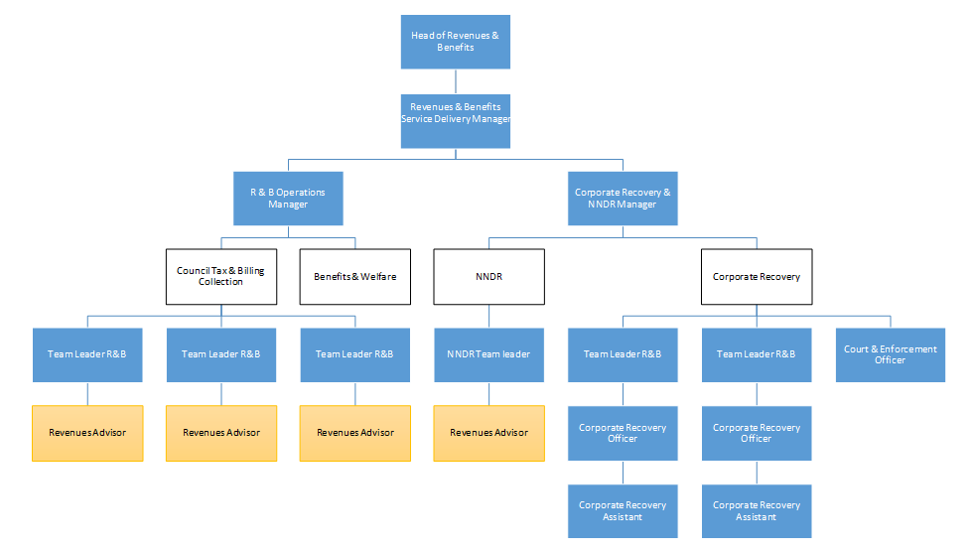

PERSON SPECIFICATION

In this section the Skills, Knowledge, Qualification and Competency requirements to perform the role to a satisfactory standard are set out. The extent, nature and level of the role holder’s knowledge and skills should be specified
Awareness some knowledge or skills sufficient to show aptitude and the ability to learn in the particular work area
Significant knowledge and skills gained through practice and/or qualification sufficient to fulfill the role requirements
Extensive knowledge and skills gained through practice and/ or qualification to fulfill the role requirements and contribute to training others and developing policy and practice in the work area

PERSON SPECIFICATION | Examples specific to role | Required |  | Level |  |  | Method of Assessment application form, interview, testing, reference
PERSON SPECIFICATION | Examples specific to role | Essential | Desirable | Awareness | Significant | Extensive
SKILLS AND KNOWLEDGE
Technical knowledge and qualifications | GCSE English & Maths grade A – C, or equivalent |  |  |  | X |  | Application / Interview
 | IRRV Technician/Level 3 or equivalent experience |  | X |  | X
 | IT literate in Microsoft Office applications | X |  |  | X
 | Experience of Council Tax/Business Rates |  | X |  | X
Planning and organising work | Ability to work accurately | X |  |  | X |  | Application / Interview
 | Experience of planning and prioritising work to deadlines | X |  |  | X
Planning capacity and resources | Ability to use resources efficiently and effectively | X |  |  | X |  | Application / Interview
Influencing and interpersonal skills | Good interpersonal and negotiation skills | X |  |  | X |  | Application / Interview
 | Good verbal and written communication skills | X |  |  | X
 | Customer focussed | X |  |  | X
 | Flexibility in working with all stakeholders of the Service | X |  |  | X
PROBLEM-SOLVING
Using initiative to overcome problems | Proven aptitude for, and experience of, working with numbers/financial calculations | X |  |  | X |  | Application / Interview
 | Positive manner of working | X |  |  | X
 | Able to question and solve practical problems and complete tasks | X |  |  | X
Managing risk | Strong commitment to equality of opportunity, diversity and promoting the rights of minority and under-represented groups, in employment and via the Service | X |  | X |  |  | Application / Interview
 | Respectful of the sensitivity of Service data and able to operate with integrity and professional judgement at all times | X |  |  | X
 | Takes responsibility for self and environment to ensure that risks are minimised, dealing with potential risks, hazards and incidents appropriately. | X |  | X
Managing change | Flexible and willing to adapt to change in busy and demanding work environment | X |  |  | X |  | Application / Interview
 | Provides suggestions and feedback on working practices to improve the Service. | X |  |  | X
ACCOUNTABILITY and RESPONSIBILITY
Undertakes tasks without supervision | Must be self- motivating and able to work on own completing required tasks | X |  |  | X |  | Application / Interview
 | Take responsibility for quality and completion of own work within standards | X |  |  | X
Managing people | n/a
Managing financial resources | Understanding of, and desire to deliver, high quality, cost effective public services | X |  | X |  |  | Application / Interview
 | Able to manage own time ensuring punctuality in work tasks; undertaking cost effective ways to recover debts | X |  |  | X

COMPETENCIES REQUIRED – All post holders must be able to comply with the Council’s core competency requirements, Leading Change, Focus on the Customer, Team Working, Delivering Performance, Motivation, and Managing Resources.

SPOKEN ENGLISH FLUENCY DUTY REQUIREMENT - The ability to converse at ease with members of the public and provide advice in accurate spoken English is essential for this post.

CORPORATE SAFEGUARDING STATEMENT – All post holders must be committed to applying and upholding the Council’s Corporate Safeguarding Policy Statement. Specific safeguarding responsibilities should be detailed in this document.

Other information e.g.
- able to travel to meet service delivery requirements
- available to undertake work outside of normal working hours

Signed Line Manager | Signed Assistant Director
Print Line Manager | Print Assistant Director | Date

