ROLE PROFILE

Role Title: Quality & Compliance Deputy Manager

Service Group: Commissioning & Contracts Team

Accountable to: Quality & Compliance Manager

Grade: H

Date: November 2018

JE code: JE1854 Competency Level: 2

Purpose of job

The post holder will report directly to the Quality & Compliance Manager (QCM) and oversee the operational management of the Quality & Compliance Team (QCT). This includes responsibility for the operational management of 4 Quality & Compliance Officers (QCO). The post holder will work with a range of providers to ensure services deliver good quality, meet their contractual obligations and deliver value for money.

The post holder will deputise for the QCM when required as the lead for Adult Social Care (ASC) and Health contracts quality & compliance, and will be responsible for the management of the 4 QCO’s, QCO assistant and the Children’s QCO.

The post holder will provide support, advice and guidance to both internal and external stakeholders on matters relating to contract monitoring of quality, compliance and performance.

Key Objectives

1 | Informing the operating performance management framework which will enable the QCT to develop priorities, monitor progress, escalate when appropriate and take corrective action
2 | To advise commissioners and the QCT on the development of contract documentation regarding the tendering of ASC and Health services including technical advice on quality, compliance and performance measures, action and activity plans
3 | Manage a team of QCO’s who monitor the quality, compliance and performance for ASC and Health contracts. Work closely with the Joint Commissioners to ensure a complementary approach
4 | Manage the systems for the collection of performance measures and targets (including equalities and value for money) for gauging the effectiveness of strategic priorities, ensuring that the performance of contracted services are regularly monitored and reviewed and that services are effective, meet statutory requirements and deliver desired outcomes.
5 | Be responsible for the provision of statistical analysis and detailed for internal and external reports and commissioning plans for relevant CCG and MKC Committees and Boards, e.g. providing evidence to the Strategic Health Authority, CQC and their successor bodies, as and when required, and the deadlines stipulated.
6 | Assisting on the analysis, benchmarking and interpretation of data and information to be presented in various formats and reports for a range of audiences to facilitate review, planning, monitoring and intervention.
7 | Ensure that all contracted services are monitored efficiently and maintained to deliver both statutory and council objectives.
8 | Lead on service users’ concerns and complaints investigations and ensure that they are properly investigated and resolved within agreed timescales.
9 | Ensure that the Contracts review/monitoring officers team is suitably equipped to deliver the targets and objectives of the Council through professional development, leadership and knowledge.
10 | Develop a partnership working approach with statutory, voluntary and  independent sector agencies in relation to contracting issues

Scope

- Report to the QCM, and work closely with the Head of Contracts and Commissioning to ensure effective commissioning, quality, compliance and performance of contracted services

- Provide advice and expertise to members of the Commissioning and Contracts team.

- To liaise with the following teams, to provide expert advice and information regarding Health and ASC providers’ performance:
  - Milton Keynes Council internal teams
  - Voluntary and Independent sector providers
  - Service users and patient representatives
  - Relevant national bodies

People: The role requires the post holder to give clear management direction to QCO’s, all engaged in quality, compliance and performance monitoring of contracts.

This role requires building strong working relationships with ASC and Health, Finance, NHS Business Intelligence, NHS Hub Colleagues (e.g. quality, commissioning), and independent providers (private and third sector) to ensure a consistent approach to procuring, monitoring, reviewing and delivering services.

The post holder will work closely in partnership with other statutory and non-statutory agencies to ensure good outcomes are achieved for vulnerable adults

Financial: The post holder will be leading a team of Contracts Review/Monitoring Officers who monitor the contract performance for Social care and Health contracts worth in excess of £100m per annum. The post holder will lead on reviewing and monitoring providers financially, to ensure viability, value for money, and identify any potential savings. The post holder will liaise with finance for any required support regarding the financial assessment and monitoring providers (if specialist advice is required).

Special factors: The post holder will have knowledge and experience of health and/or social care services and experience of implementing performance management frameworks and undertake analysis of systems and data.

Work Profile

Quality, Compliance and Performance Management

- To implement and deliver a robust and effective performance management framework for the contracts held by the Commissioning and Contracts Team as well as other relevant Health or Social Care contracts which will enable the Commissioning and Contracts Team to deliver their objectives and have sufficient knowledge to challenge underperformance and ensure corrective action is taken

- Lead on reviews of capacity, suitability and cost effectiveness of contracts

- Support robust performance management, accountability frameworks and new service models including the development of clear communication channels with all stakeholders

- Work with and support providers, care homes, domiciliary care agencies and supported living organisations to improve quality, compliance and performance. Undertake action plans to remedy under performance and non-compliance of contractual obligations

Liaise with local providers to develop effective markets, improve understanding of MKC contractual requirements and service developments to ensure quality responses to tender opportunities. This will include working with colleagues to develop customer satisfaction surveys and other means of ensuring that service user’ expectations are met.

- Identify and develop improvement opportunities and efficiency savings

- Ensure value for money is achieved for contracted savings

- Ensure that national frameworks are delivered and applied effectively as part of the quality, compliance and performance management framework

- Work closely with other departments and organisations that have a performance and information team, establishing the information requirements to ensure a robust performance management system, including the reporting cycle

- Develop the team business plan for the quality & compliance team, deliver against the key elements of the service plan, corporate plan and CCG strategic plan for objectives related to the health and social care contracts management and delivery of external service provision

- Lead on the shaping and development of existing and future local services to meet the needs of people living in Milton Keynes. As part of this process, a prioritised programme of new and re-provided services will be managed to ensure that contracts are awarded to meet this programme

- Assist in the procurement processes for new and re-tendered services, to help commissioners in specifying services and setting up the quality, compliance and performance monitoring requirements for new contracts

- Manage and monitor the work and performance of the QCO’s (4) and provide feedback to the Head of Contracts, QCM on contract compliance. Provide feedback on providers quality, compliance and performance to inform the process of reviewing contractual arrangements

- Conduct individual staff supervision, appraisals, identifying training and development requirements to sustain and enhance staff performance. Contribute to the development of workforce plans to ensure that there is a skilled workforce able to meet new expectations and changing needs

- Set operational targets and objectives, allocate work, establish work and quality programmes for the QCO’s

- Undertake staff selection procedures and appointments of QCO team staff, in line with MKC procedures

- Responsible for all matters of discipline and performance of QCO’s, in line with MKC procedures, deal with disciplinary and grievance procedures at the earlier stages

- Promote equality of opportunity and diversity for all employees and service users in line with the Council’s policies and procedures

- Maintain personal and professional development to meet the changing demands of the role, participate in appropriate training / development activities and encourage and support staff in their development and training

Communication and Relationships

- Be a source of advice and guidance to colleagues throughout the Commissioning and Contracts Team on matters relating to Quality, Compliance and Performance management

- Be responsible for developing and sustaining appropriate relationships with service providers

Other

- Lead on information and advice on the performance management aspects of contract documentation relevant to tendering and re-tendering processes, including service specifications and the setting up of new contracts Quality, Compliance and Performance monitoring

- Utilise appropriate qualitative and quantitative research methods in the application of the performance

- Make available accurate, timely information to support the monitoring and management of contracted services

- Adhere to the Standing Financial Instructions and Financial Procedures that are in operation

Job Context

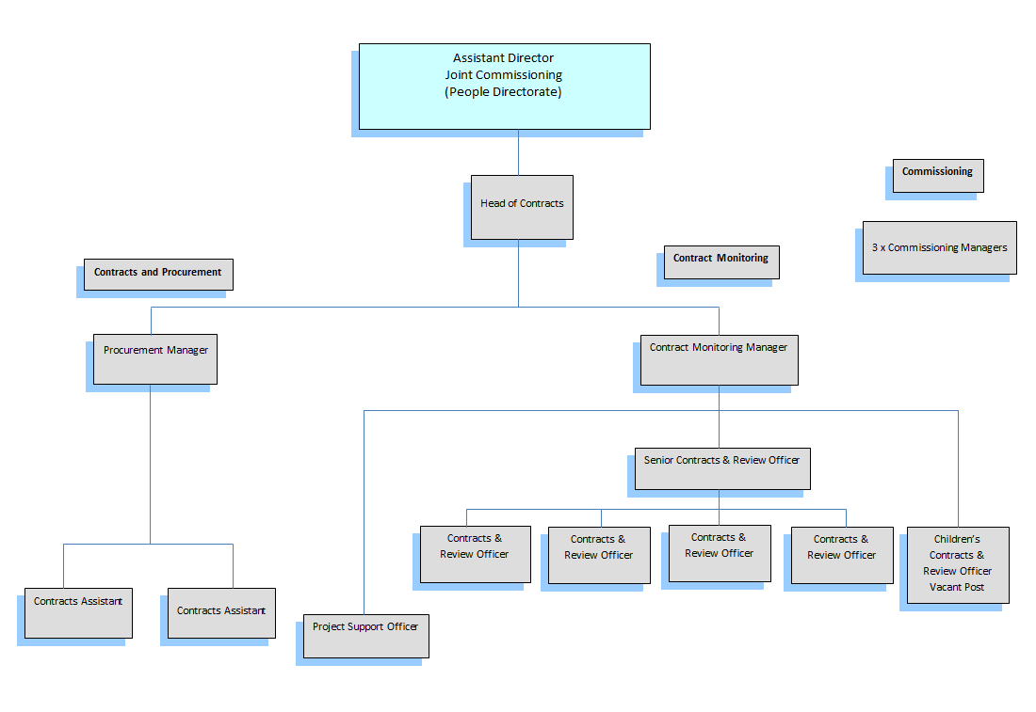

PERSON SPECIFICATION

In this section the Skills, Knowledge, Qualification and Competency requirements to perform the role to a satisfactory standard are set out. The extent, nature and level of the role holder’s knowledge and skills should be specified
Awareness some knowledge or skills sufficient to show aptitude and the ability to learn in the particular work area
Significant knowledge and skills gained through practice and/or qualification sufficient to fulfill the role requirements
Extensive knowledge and skills gained through practice and/ or qualification to fulfill the role requirements and contribute to training others and developing policy and practice in the work area

PERSON SPECIFICATION | Examples specific to role | Required |  | Level |  |  | Method of Assessment application form, interview, testing, reference
PERSON SPECIFICATION | Examples specific to role | Essential | Desirable | Awareness | Significant | Extensive
SKILLS AND KNOWLEDGE  Technical knowledge and qualifications | Strategy Formulation  - Evidence of successfully implementing strategy and policy for contract management  Analysing Date  - Shows understanding and implementation of whole systems thinking and related “lean” approaches to service improvement and operations management  - Advanced use of IT packages  - Good organisational aptitude  - Budget and finance analysis / monitoring / review  Qualifications  - Professional qualification (management, health or social care  - Evidence of commitment to continuing professional development  Experience  - At least 3 years’ experience of working in performance or contract management for the NHS or Social Care in a Local Authority  - Knowledge and working experience of Joint Commissioning  - Experience in managing staff  - Excellent verbal and written communication skills | X  X  X  X  X  X  X  X  X  X | X |  | X  X  X | X  X  X  X  X  X  X  X
Planning and organising work | - Demonstrated ability to organise others not directly under his or her control, for example, a project team  - Ability to analyse, summarise and write / record relevant information clearly and concisely so that it is easily understood by colleagues  - Ability to prioritise workloads and achieve deadlines | X  X  X |  |  | X  X | X
Planning capacity and resources | - Demonstrates the ability to plan actions and events effectively, taking into account the needs of others at all levels within the organisation  - Able to allocate work and ensure resources available are utilised to meet demand effectively | X  X |  |  | X | X
Influencing and interpersonal skills | Building productive working relationships  - Ability to build effective relationships and achieve co-operation from others as demonstrated by evidence of success in working productively with other organisational departments, stakeholders and providers  Influence and negotiation skills  - Evidence of negotiation and influencing skills, and having successfully used them as part of a current / previous role  Co-operation  - Evidence of having worked successfully with others outside his or her own specialism  - Ability to establish good working relationships with providers  Persuasion  - Succeeded in challenging colleagues opposed to change (internally and externally), including those senior to himself/ herself and having implemented that change successfully  - Demonstrates diplomacy and tact in dealing with controversial situations  - Demonstrated the ability to handle confrontational situations well  - Ability to develop and sustain partnerships with other professionals and agencies through trust and credibility  - Able to chair inter agency meetings  Customer Focus  - Demonstrates having delivered agreed outputs to required standards within tight deadlines  - Evidence of having worked effectively with various types of customer demands  - Evidence of having delivered outcomes based on customer demand appropriately | X  X  X  X  X  X  X  X  X  X  X  X |  |  | X  X  X  X  X  X | X  X  X  X  X  X
PROBLEM-SOLVING  Using initiative to overcome problems | Problem Solving  - Evidence and knowledge of problem solving techniques for complex situations, including analysis and recommending solutions  - Demonstrates the ability to find creative solutions to problems  - Ability to question, challenge, solve problems and complete tasks  - Assessment skills – ability to demonstrate understanding of process and evidence of ability to apply skills  - Able to analyse complex information and make decisions for team members in high risk situations  Initiative  - Evidence of having identified problems and corrected them on his or her own initiative  - Well-developed interpersonal and communication skills with a wide range of audiences  - Team working, the ability to work with others to achieve objectives and to support colleagues  - Evidence of being able to work autonomously and as part of a team, to determine priorities, take appropriate decisions, manage projects and delivery to deadlines | X  X  X  X  X  X  X  X  X |  |  | X  X  X  X  X  X  X  X  X
Managing risk | - Ability to assess various kinds of risk and success in identifying and analysing risks  - Ability to recognise emotional risk to others resulting from the work  - Able to make considered decisions, analyse and evaluate complex information in high risk situations  - Demonstrates an understanding of risk to customers of failure to meet their demand and the actions required to minimise it  - Demonstrates evidence of managing risk effectively by taking appropriate actions and achieving a successful outcome | X  X  X  X  X |  |  | X  X  X  X  X
Managing change | - Able to support and motivate staff to deliver changes in practice, team structures and joint working in line with local and national requirements  - Demonstrates evidence of having successfully implemented change  - Understands the mechanisms of change management and able to recognise adverse effects on others  - Able to propose and implement solutions to staff arising from change | X  X  X  X |  |  | X  X  X  X
ACCOUNTABILITY and RESPONSIBILITY  Undertakes tasks without supervision | - Must be self-motivating and able to make difficult decisions and support staff in complex work, supervise and appraise staff  - Takes responsibility for the team, under guidance of team manager, the service delivered and the decisions made  - Able to work independently with minimal supervision  - Able to take action without recourse to others when need arises in the course of an intervention | X  X  X  X |  | X | X  X  X
Managing people | - High level skills and knowledge in managing and motivating professional staff in a complex work areas and environment  - Able to co-ordinate the work of others, as a leader  - Experience of managing staff | X  X | X |  | X  X | X
Managing financial resources | - Able to show evidence of having identifies and implemented value for money for contracted services | X |  |  |  | X

COMPETENCIES REQUIRED – All post holders must be able to comply with the Council’s core competency requirements, Customer Focus, Communicating and Engaging, Managing Resources and Risk, Organising and Improving Performance, Taking Responsibility, Team Player, and Excellent Leadership

SPOKEN ENGLISH FLUENCY DUTY REQUIREMENT - The ability to converse at ease with members of the public and provide advice in accurate spoken English is essential for this post

Other information e.g.
- able to travel to meet service delivery requirements
- available to undertake work outside of normal working hours

Signed Line Manager | Signed Service Director
Print Line Manager | Print Service Director | Date

