ROLE PROFILE

Role Title: Personal Education (PEP) Quality and Compliance Officer – Children who are Looked After (CLA) Education Team

Service Area: Settings and School Effectiveness

Directorate: Children and Families

Accountable to: Virtual Head Teacher – CLA Education Team

Grade: E

JE1117

Purpose of job

- To ensure that all relevant LA colleagues are fully updated with regard to Pupil Education Plans (PEP) legislation and ensure the LA Social Workers and the Designated Teachers in schools are compliant and timely with regard to the statutory requirements of the Pupil Education Plans (PEPs) of Children who are Looked After (CLA).

Key Objectives

1 | To contribute to the design, development, review and revision of the annual Setting and School Organisation Framework document.
2 | To ensure that all PEP procedures are carried out fully and for all CLA, in line with statutory regulations, guidance and timeframes by Social Workers, CLA Designated Teacher and other relevant parties
3 | To ensure that educational establishments are aware of their statutory responsibilities and are compliant.
4 | To review all systems and procedures on a regular basis to reflect changes in legislation and policy
5 | To ensure all publications and web pages are compliant with legislation and compliant with corporate arrangements and reflect best practice
6 | Lead on the updates to the Liquidlogic (or any other relevant data system) required to support effective and accurate recording of PEP data and ensure distribution according to legislation
7 | To ensure all CLA funding received by educational establishments is being utilised in a high quality manner to benefit the intended recipient and is contributing toward maximum educational progress

Scope

The role holder will work directly with other professionals including social workers, CLA Designated Teachers, foster carers and parents. They will have contact with vulnerable children and young people who have significant needs due to trauma and associated attachment difficulties in order to ascertain their views on their education provision and the support provided for them.

The role holder will pay a significant part in agreeing the support offered to CLA/Care Leavers. They will be expected to challenge professionals to ensure that CLA/Care Leavers are receiving appropriate support to promote good or accelerated progress in education and key milestones, to attain high levels of achievement to secure future economic well- being.

The role holder will be responsible for identifying key transitions and ensure PEPs take place on these occasions to support successful transitions.

The role holder will be responsible for the accurate recording of all contact with CLA/Care Leavers, professionals and other agencies according to the guidelines of The Virtual School development plan.

The role holder will operate in a framework of safe practice following all health and safety guidelines, undertaking risk assessments where appropriate.

NON FINANCIAL MANAGEMENT

The role holder will influence Social Workers, schools, placements and other settings to ensure that each CLA has an up to date PEP completed and recorded in line with statutory policy and legislation.

The role holder will monitor and ‘quality assure’ all PEPs recorded to ensure they are a robust working document which informs practice.

The role holder will be expected to monitor and challenge educational establishments on the effective use of additional funding allocated specifically to promote good or accelerated progress.

Direct budget There is no direct budget

Staff There is no line management responsibility

Work Profile

- To contribute to the aims and objectives of Children and Families as set out in the strategic, service and team plans and will play an effective part in achieving the corporate objectives of the council

- To work with the Virtual Headteacher to draft and review sections of the school organisation framework and other publications for parents, carers and other professionals including information about PEP protocol and website access and upkeep

- To develop and maintain high quality relationships with other agencies, including settings, schools, academies, free schools and trusts, health professionals, parents, carers and social workers.

- To ensure that Milton Keynes Council’s PEP processes are up to date and in line with legislation by managing the appropriate consultation, summarising responses and making recommendations to the Head of Delivery about the changes required.

- To monitor the arrangements with the CLA Education Officers with regard to PEP meetings to ensure social workers, CLA Designated Teachers and other professionals are compliant with legislation and policy.

- To attend all PEP meetings in Milton Keynes and local authorities across the country to ensure robust and consistent reporting, discussion and setting of SMART targets for young people. To challenge schools support of CLA to ensure that individual needs are being met and educational progress is good or outstanding

- To undertake regular audits to ensure the PEP is a quality document that informs practice.

- To take responsibility for summarising and reporting on all consultation exercises in order to effectively support decision making and to keep the Virtual Headteacher fully informed.

- To ensure that the Liquidlogic system (or any other relevant data system) is used to its potential to support an effective and legally compliant PEP reporting platform

- To maintain an up to date knowledge of relevant changes to legislation and guidance and highlight the impact of such changes to the Head of Delivery and the CLA education team and other appropriate teams within the LA and schools.

- To support the Virtual Headteacher and CLA Education Officers to maintain the content of the CLA team webpages and publications with regard to PEP protocol.

Job Context
Proposed new structure for CLA Education Team

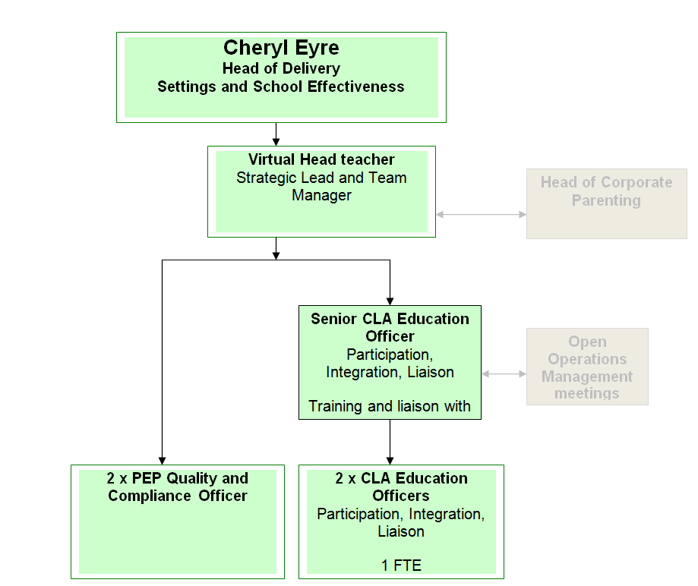

PERSON SPECIFICATION

In this section the Skills, Knowledge, Qualification and Competency requirements to perform the role to a satisfactory standard are set out. The extent, nature and level of the role holder’s knowledge and skills should be specified
Awareness some knowledge or skills sufficient to show aptitude and the ability to learn in the particular work area
Significant knowledge and skills gained through practice and/or qualification sufficient to fulfil the role requirements
Extensive knowledge and skills gained through practice and/ or qualification to fulfil the role requirements and contribute to training others and developing policy and practice in the work area

PERSON SPECIFICATION | Examples specific to role | Required |  | Level |  |  | Method of Assessment interview, testing, reference
PERSON SPECIFICATION | Examples specific to role | Essential | Desirable | Awareness | Significant | Extensive | Method of Assessment interview, testing, reference
SKILLS AND KNOWLEDGE  Technical knowledge and qualifications | - Educated to NVQ level 3 or equivalent or demonstrable experience of working in a role requiring this level of skill and knowledge  - Knowledge of school organisation legislation, guidance and practice  - Knowledge of corporate policy and procedure relating to communication, consultation and change  - Knowledge of local democratic processes and procedures  - Understanding of revenue and capital funding streams  - Understanding of structures and systems within which school organisations operate | Y  Y  Y  Y | Y  Y | Y | Y  Y  Y | Y  Y | Interview  Interview  Interview  Application  Interview  Interview
Planning and organising work | - Ability to prioritise a large number of varied tasks to meet a range of deadlines  - Ability to work under pressure to deliver at very short notice | Y  Y |  |  | Y  Y |  | Interview  Interview
Planning capacity and resources | - Ability to plan and organise complex and interrelated work streams  - Ability to plan across short, medium and long term  - Ability to understand and manage the milestones required in order to adhere strictly to the timelines laid out in regulation and guidance | Y  Y  Y |  |  |  | Y  Y  Y | Interview  Interview  Interview
Influencing and interpersonal skills | - High level interpersonal skills  - High levels of personal integrity  - Demonstrates resilience under pressure  - Ability to explain complex principles , legal concepts and guidance  - Highly developed written skills which enable complex proposals to be communicated accessibly to a wide range of stakeholders  - Ability to answer difficult questions in a public forum | Y  Y  Y  Y  Y  Y |  |  |  | Y  Y  Y  Y  Y  Y | Interview  Interview  Interview  Interview  Interview  Interview
PROBLEM-SOLVING  Using initiative to overcome problems | - Ability to come up with creative, solutions to challenges in line with legislation and policy | Y |  |  |  | Y | Interview
Managing risk | - Ability to identify risks and put in place suitable mitigation plans to minimise possible impact | Y |  |  |  | Y | Interview
Managing change | - Experience of managing and delivering organisational change in a complex environment | Y |  |  |  | Y | Interview
ACCOUNTABILITY and RESPONSIBILITY  Undertakes tasks without supervision | - Ability to work autonomously with little supervision  - Ability to manage projects, set own milestones and deliver to deadlines with little supervision | Y  Y |  |  |  | Y  Y | Interview  Interview
Managing people |  | Y |  |  |  | Y | Interview
Managing financial resources | - N/A

COMPETENCIES REQUIRED – All post holders must be able to comply with the Council’s core competency requirements which include communication, respect for others, customer service, drive for results, delivering the promise and continuous personal development.

SPOKEN ENGLISH FLUENCY DUTY REQUIREMENT - The ability to converse at ease with members of the public and provide advice in accurate spoken English is essential for this post.

In addition for those posts with management responsibilities the competencies will include managing self and personal skills, providing direction, facilitating and managing change, working with people, using resources, achieving results, promoting policy, values and culture, customer service and health and safety.

Other information
- able to travel to a variety of venues, including locations outside Milton Keynes meet service delivery requirements
- available to undertake work outside of normal working hours

Signed Job holder | Signed Line Manager | Signed Service Head | Date

