ROLE PROFILE

Job Title | SOCIAL WORKER (ASC) L3
Directorate | Community Wellbeing
Section | Adult Social Care
Accountable to | Team Manager or Senior Practitioner
Grade | H
JE Code | JE0216

Purpose of Role
To carry out the duties of a professional Social Worker within Adult Social Care. To assess the needs of adults and determine if they meet the Milton Keynes eligibility criteria for receiving social care. To assess the needs of their families and informal carers. To analyse information and ensure timely and effective interventions to meet eligible needs To make sure that support plans are developed and implemented that ensures the adult’s safety, well being and independence in order to lead a fulfilled life. This is to be completed in accordance to the terms and guidance of the relevant legislation and professional code of practice.

Key Objectives (list what outcomes are essential)

1. | Assessment of the needs of adults. Providing clear evidence which fairly and accurately determine the level of need and outcomes identified with the service user.
2 | Ensure that any interventions or services support the service user in way that enhances their independence, choice and wellbeing
3 | Monitor and review support plans and services in place to ensure that eligible needs are met in a way that the service user has determined
4 | Balance the varying demands of a social work caseload, maintain accurate individual case records and ensure that all required reports are completed.
5 | Participate in supervisory meetings and appraisals with team manager and/or a senior member of staff on a regular basis ensuring that the line manager is adequately informed about cases and practice, be responsible for own development and identifying training needs.
6 | Undertake and/or support Safeguarding investigations and other specialist assessments specific to the service area and level of training and career grade of the post holder.
7 | The post holder works closely with other agencies and services in a co-operative way, sharing information and planning care together to meet the needs of the adult holistically.
8 | To be able to offer supervision to support staff as required.
9 | To ensure the efficient and effective use of resources to meet identified outcomes proportionate to levels of need and eligibility.

Scope

This role is the third level in the career grading for professionally qualified social worker. At this level the post holder should be experienced and be able to demonstrate a confident and authortive approach to the role. The post holder will be able to manage a complex and challenging case and represent the Department appropriately. At this level the post holder will work with a greater level of independence and be able to demonstrate some emotional resilience to what can be a challenging role.

The post holder will be working closely with adults and their families and carers.

The post holder will also work in partnership with other statutory agencies as well as the private and voluntary sector, carers and advocacy groups.

The post holder will take lead responsibility in difficult circumstances for example in safeguarding investigations which will require close liaison with a range of organisations.

The post holder will use their professional skills to carry out person centred outcome focused assessments, in line with the assessment framework.

The post holder will work in partnership with support planners to develop, validate, implement, monitor and review the effectiveness of support plans and interventions to improve the safety, well being and independence of the person.

The post holder will be part of a multidisciplinary team and is expected to participate and contribute to team meetings and the development of their team and the wider service.

Within the framework of professional accountability and professional line management the post holder will utilise excellent assessment, analysis and judgement skills to ensure good outcomes for service users. The social worker will work in an authorative and systemic way with the whole family and key services to improve outcomes for the service user.

The role requires regular liaison with colleagues across the directorate, the Council and partner agencies. The post holder will work alongside other agencies and family services to provide a comprehensive range of support services and solutions.

The post holder’s recommendation will inform the allocation of resources for individual service user. It is essential that these recommendations are informed and well evidenced as the outcome will inform spending of the social care budgets.

Work Profile

- Undertake the Council’s duties in relation to the NHS and Community Care Act and other legislation which places a responsibility on MKC- Adult Social Care.
- Undertake initial and re-assessments of the needs of adults with community care needs who meet eligibility criteria.
- Keep timely, accurate and detailed records on the relevant systems.
- Ensure that all assessments accurately reflect needs and are person centred and outcome focused.
- Undertake assessments of the needs of informal carers and work with them to support them in their caring role.
- Monitor and review support plans to ensure that they continue to be both effective and person centred
- Respond appropriately in dealing with emergencies and crisis situations, ensuring that arrangements are in place to keep people safe and well. Where ever possible responses should be proactive with the post holder being able to competently anticipate risks.
- Provide both formal supervision and mentoring to new and less experienced staff within the service
- Deliver training within the in house training courses or contribute in other ways to wider service development
- To manage a caseload and ensure that work is completed as agreed with line manager and performance targets are met.
- To undertake safeguarding investigations and implement safeguarding plans when appropriate training and required career grade achieved.
- To undertake the supervision of support staff as required.

Job Context

Older People’s Services
Services Manager Older People & Physical Disability Range 13
Team Manager Physical Disability Team (Under 65s) Range 10 Full Time
Team Manager Adult Social Care Access Team Range 10 Full Time
Adult Protection Co-ordinator Range 10 Full Time
Team Manager Hospital SW Team Range 10 Full Time
Community Development Officer Ethnic Minorities Range 7 (25 Hours)
Team Manager Older People's Team Range 10 Full Time
Assistant Contracts Manager Range 9
Social Workers Range 6 to 8 6.5 FTE
1 Social Work Assistant Range 5/6 Full Time
1 Social Rehabilitation Officer Range 6 Full Time
3 Support Workers Range 4 Full Time
Senior Practitioner
(Safeguarding Vulnerable Adults) Range 9 Full Time
Social Workers Range 6 to 8 (8 Posts) 6.62 FTE
Social Workers Range 6 to 8 (11 Posts) 9.21 FTE
Senior Practitioner Range 9 Full Time
Customer Liaison Officer Range 6 Full Time
Social Work Assistants Range 5/6 (2 Posts) 1.64 FTE
Support Workers HIV/AIDS Range 4 (2 Posts) 1.62 FTE
Social Workers Range 6 to 8 (9 Posts) 9.27 FTE
Social Work AssistantsRAnge 6 (3 Posts) 3.0 FTE
Project Co-ordinator Range 7
Purchasing Assistants Range 6 1.68 FTE
Safeguarding
Assistant Range 5 Full Time
Senior Practitioner (Social Work)
Range 9 Full Time
Taxicard Direct Payments Officer Range 5
FTE
Customer Liaison Officers Range 6
(4 postst)
Social Work Assistants Range 5/6
Support Worker Range 4
(3 Posts)
Social Work Assistant Range 5/6
Support Worker Range 4
(2 Posts)
Operational Director
Joint Mental Health Services
Operational Manager
Operational Manager
Team Manager
Acute Care Pathway
Team Manager
ASTI/EIS
Team Manager
ERT
Social Workers
(AHTT AOT)
Social Workers
Social Workers
Social Workers
Team Manager
WRT
Joint Services Manager
253042

07949 202094
Service Coordinator
222944/324002
07904 066131

Social Worker
25 3513
07984 763143
Specialist Dr. (PCT)
253001
0776 850 4957

SCIP Trainer (PCT)
0788 0553 825 / 257965

BST Manager (PCT)
257938
0788 182 1325

Counsellor (PCT)
257937
0788 182 1704
Service Coordinator
Tower Dr Special Needs
252674/4467
07903 559583
PCP Co-or/Transitions
257954
07940138337

Comm. Support Manager
222944
07949 202083
S/Worker/Transitions
253997
0790 932 5286
Team Manager –Intake & Assessment
252206
07984562669

Team Manager
Intake & Assessment (PCT) 253391
0788 182 1862

Development Manager, Day Opportunities & Employment
372811/258082
07949 201293

Consultant Lead Clinical Psychologist (PCT)
253001

Team Manager Quality & Review
257957
07904 126096
Community Nurse
M H (PCT)
25 7951
0788 182 1778

Social Worker
25 3433
07940 138721
Social Worker
253586/
0790 4083993
Occ. Therapist (PCT) / 257963
0788 182 1480

Occ. Therapist
(PCT) 257964
07881 821539

Community Nurse
(PCT) 25 7952
0788 182 1695
Service Coordinator
W/Way & Surrey Rd
258085
07903 559567
Tower Drive: 252670
Whaddon Way: 271450
Beanhill: 674880
Surrey Road: 372811
Service Coordinator
Equality Works–Tower Dr
252684
07903 559566

CSW for BST
(PCT) 257939
0788 182 1829

Training Co-ord.
257958
0794 920 2098

Community Nurse
(PCT) 257950
07903825296

Information Officer
(PCT) 253367

Details of CS Staff on Page 2

Please find details of all Day Services staff on Page 3

Daisy Aitken
Acting Deputy Unit Manager (PCT)
Team Clerk
222944
Community Nurse
257753
07881821486
Nurses & Care Staff
222944
Team Clerk

Community Support Team
Consultant Psychiatrist
(PCT) 253001
Social Worker
253001
07947 577608
February 2010 200992092009
Service Coordinator
ECCO
258086/ 07904 460134

Clinical Psychologist
(PCT) 253001
07881821557

CAW/ Transitions 258087
07904085518

Neath Hill
01908 253001
Social Worker
25 3628
07950 576162

Social Worker
253880
07904 085521
Vacancy
Dietitian

Social Worker
253431 / 07940138147

CSW BST
(PCT) 257943
07957217899
Secretary Team Administrator
253312
2533121
257966
CSW (PCT)
257962
0788 1821903

S.L.T (PCT)
257948
0777 064 7867

S.L.T. (PCT)
257948
0798 552 3991
Team Clerk
253549

Medical Secretary/
Team Administrator
(PCT) 257944
Team Clerk
257966

Physiotherapist (PCT)
257960
07881 821770

Physio Assistant
(PCT) 257961
0776 644 1859

Community Access Worker
257955 /
0790 382 5287
SLT. (PCT)
257947
0779 934 8353
Physiotherapist
(PCT) 257959
0777 072 8892

Reviewing Officer
257956 /
07985865549

S.L.T. Assistant (PCT) 257949

Vacant
Team Manager
MH & LD
253391/

Oakwood
Unit Manager (PCT)
282072
Acting Deputy Mgr (PCT)
Unit Manager
282072
Admin, Nurses & Care Staff
Project Manager (PCT)
222944
0776 8038 897
Mathiesen Road Short Breaks 225164/
312558/312616

(PCT)
Deputy Manager

HAT Lead (PCT)
257945/
07940 138 821
HAT (PCT)
254353/
07940 408 5516
HAT (PCT)
25

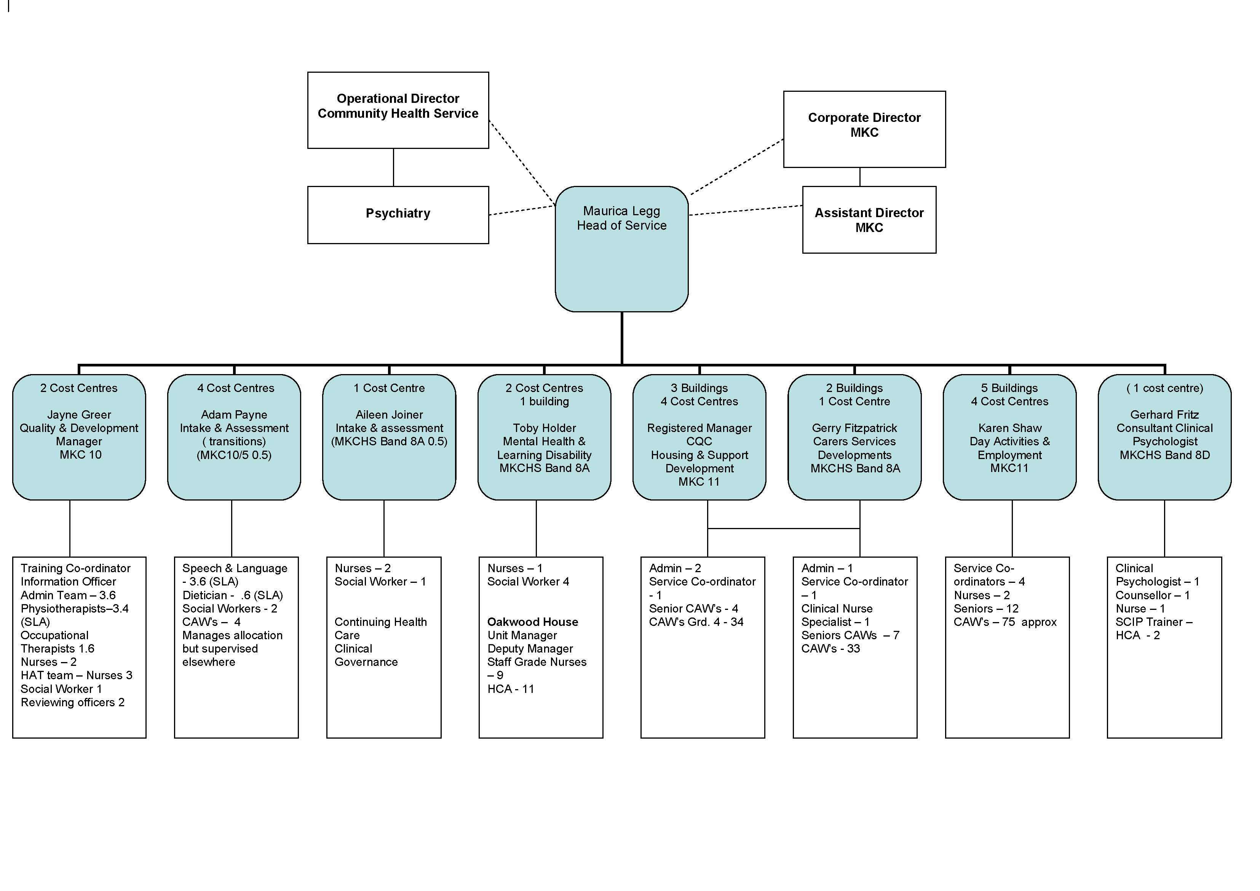
Joint Role
MKC / PCT
Intermediate Care Service Manager
MKC Manager

Operational Manager
Intermediate Care Team

PCT Manager

RAIT Manager
PCT Manager

Unit Manager
Windsor Intermediate Care Unit
Joint Role
MKC / PCT
Senior Admin/Sec to IC Service Manager

MKC Posts

9 x Team Leaders

MKC Posts

31 x Carers
MKC Posts

2 x Admin
1 x Sen ICLO
2 x ICLO

PCT Posts
6 x Carers
PCT Posts

3 x FT Nurses
5 x PT Nurses
MKC Post

2 x Social
Workers
1 x SW Assistant
MK General
Hospital Post
Report to RAIT Mgr operationally
2 x Physio
2 x OT & 1 x SALT
PCT Posts

6 x Team Leaders
PCT Posts

Band 5 RGN and Ward Staff
PCT Posts

4 x Nursing Staff
2 x Rehab Assistants
MK General
Hospital Posts
Report to Unit Mgr operationally
Therapy Staff

PCT Post

1 X Admin

PERSON SPECIFICATION

In this section the Skills, Knowledge, Qualification and Competency requirements to perform the role to a satisfactory standard are set out. The extent, nature and level of the role holder’s knowledge and skills should be specified
Awareness some knowledge or skills sufficient to show aptitude and the ability to learn in the particular work area
Significant knowledge and skills gained through practice and/or qualification sufficient to fulfil the role requirements
Extensive knowledge and skills gained through practice and/ or qualification to fulfil the role requirements and contribute to training others and developing policy and practice in the work area
PERSON SPECIFICATION | Examples specific to role | Required |  | Level |  |  | Method of Assessment interview, testing, reference
PERSON SPECIFICATION | Examples specific to role | Essential | Desirable | Awareness | Significant | Extensive | Method of Assessment interview, testing, reference
SKILLS AND KNOWLEDGE  Technical knowledge and qualifications | Social work qualification (DipSW, CQSW, Degree in Social Work or equivalent)  Post qualification award  Registered with the GSCC  Practice teaching award  Safeguarding Investigators Training | X  X  X | X  X |  |  | x | Application form
Planning and organising work | Ability to analyse, summarise and write/ record relevant information clearly and concisely so that it is easily understood by users and colleagues  Excellent verbal and written communication skills  Good IT skills | X  X  X |  |  | X | X  X | Interview and test
Planning capacity and resources | Able to manage own work, prioritise, plan and use time efficiently.  To be able to act on initiative, and to respond to emergency and crisis situations  Flexible and willing to support other staff when need arises. | X  X  X |  |  | X  X | X | Interview and test
Influencing and interpersonal skills | Ability to work as part of a team including working co-operatively with other professionals and agencies  To be able to engage with service users, families and carers with diverse and often complex needs to ensure meaningful and productive interventions are developed and agreed.  To be able to work confidently with conflict  To be effective in managing self | X  X  X | X |  | X  X | X  X | Interview and test
PROBLEM-SOLVING  Using initiative to overcome problems | Skills and knowledge in listening to adults with complex needs, observing and making informed decisions based on information received and assessed  Able to collect, analyse and make judgements about complex information.  Able to develop, implement and monitor outcome focused support plans.  Able to be person centred and treat all with respect and with empathy  Ability to question, challenge, solve problems and complete tasks | X  X  X  X | X |  | X  X | X  X  X | Interview and test
Managing risk | To complete detailed risk assessments based on information from varied sources acknowledging that people have the right to make decisions and choices which may be considered unwise.  Able in consultation with manager, to make considered decisions, analyse and evaluate complex information in high risk situations.  Ensure service users service users are enabled to make informed choices and live their lives to the full  To implement safeguarding and risk minimisation plans | X  X  X  X |  |  | X | X  X  X | Interview and test
Managing change | Flexible and able and willing to adapt to change in work processes and procedures | X |  |  |  | X | Interview and test
ACCOUNTABILITY and RESPONSIBILITY  Undertakes tasks without supervision | Must be self- motivating and able to work on own in complex environment.  Takes responsibility for quality and completion of own work within required standards | X  X |  |  | X  X |  | Interview and test
Managing people | With appropriate experience able to supervise and social work assistants, support planners/ Community Access Workers |  | X |  | X |  | Application form
Managing financial resources | Able to manage own time.  To find cost effective and efficient solutions to meet needs and outcomes. | X  X |  |  | X  X |  | Interview and test

COMPETENCIES REQUIRED – All post holders must be able to comply with the Council’s core competency requirements which include communication, respect for others, customer service, drive for results, delivering the promise and continuous personal development.

SPOKEN ENGLISH FLUENCY DUTY REQUIREMENT - The ability to converse at ease with members of the public and provide advice in accurate spoken English is essential for this post.

In addition for those posts with management responsibilities the competencies will include managing self and personal skills, providing direction, facilitating and managing change, working with people, using resources, achieving results, promoting policy, values and culture, customer service and health and safety.

Other information
- able to travel to meet service delivery requirements
- available to undertake work outside of normal working hours

Signed Job holder | Signed Line Manager | Signed Service Head | Date

