ROLE PROFILE

Role Title: Customer Liaison Officer

Service Area: Education Sufficiency and Access

Directorate: People

Accountable to: Education Sufficiency Manager or Education Access Manager

Grade: D

JE code: JE1348

Purpose of job

The purpose of the job is to act as a single point of contact for customers, both public and professionals who contact the council in relation to any aspect of children’s access to early years and school, which comprises of school place sufficiency, access to early years and childcare, school admissions, free school meals and home to school transport.

Key Objectives

1 | Provision of comprehensive, specialist information and advice service for customers who require help and support in accessing education
2 | Process applications for two year old places, free school meals, school places and home to school transport promptly and accurately with a target turn around of five working days
3 | Accurately co-ordinate the admissions process for children due to start school, transfer to junior school or start secondary school each year, meeting all national deadlines
4 | Meet parents, carers, social workers and other professionals to support those unable to easily independently access the service to do so with high quality support

Scope

This post involves dealing with a high volume of often continuous telephone calls on a daily basis (which queue) and/or high volumes of emails from various members of the public. The contact will often be complex and multi faceted (see the services outlined in the purpose), requiring the post holder to both listen and process information as well as offering accurate, professional advice, but at the same time ensure that the transaction is completed as quickly as possible to enable others to access the service. Customers can often be upset, angry, anxious or confused, requiring the post holder to be skilful in their handling of the transaction. Occasionally the post holder will need to meet members of the public face to face. Other customers include professionals such as social workers who will be attempting to help a vulnerable family to access our services. The post holder will be expected to handle the vast majority of the contact, but will have the ability to escalate unhappy customers to the manager.

Work Profile

Answer telephone calls and emails about all aspects of the services in scope, offering high quality advice and information in a professional manner at all times

Accurately process applications for access to the services, including free school meals, two year old eligibility, school admissions and home to school transport

Meet members of he public who wish to discuss their applications or need help

Attend targeted events and focus groups to support groups of parents/carers to understand how to access the service

Carry out processes and procedures in relation to the council’s role to co-ordinate the process for children transferring from school to school at normal points of exit and entry

Communicate appropriately with schools regarding families’ access needs

Liaise with schools that are their own admissions authorities regarding their willingness to admit children

Accurately update appropriate databases with new information

Escalate complaints quickly and appropriately

Regularly report issues, cases and areas of concern where access to education is proving challenging for our customers

Job Context (attach the organisation chart(s) relating to the role)

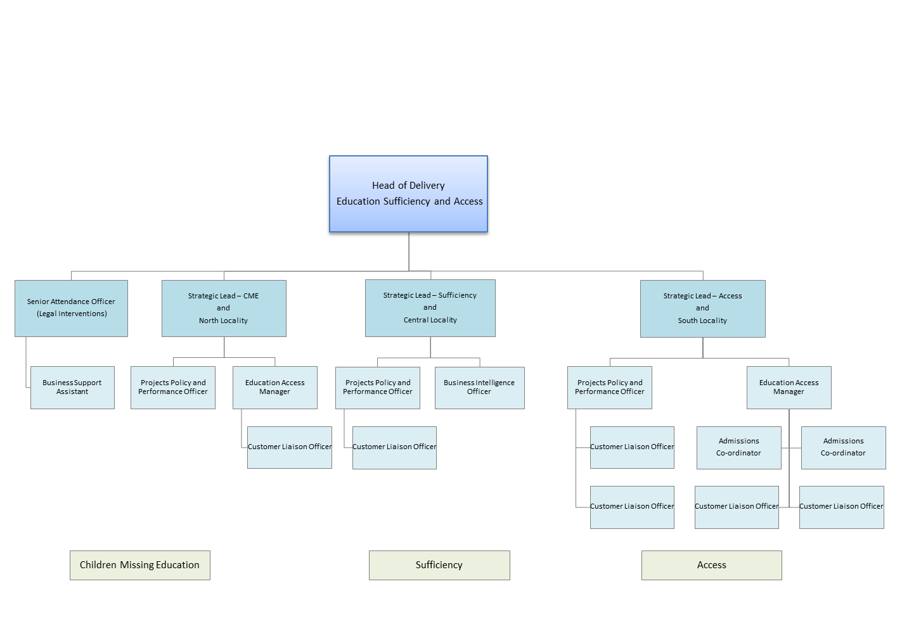

PERSON SPECIFICATION

In this section the Skills, Knowledge, Qualification and Competency requirements to perform the role to a satisfactory standard are set out. The extent, nature and level of the role holder’s knowledge and skills should be specified
Awareness some knowledge or skills sufficient to show aptitude and the ability to learn in the particular work area
Significant knowledge and skills gained through practice and/or qualification sufficient to fulfill the role requirements
Extensive knowledge and skills gained through practice and/ or qualification to fulfill the role requirements and contribute to training others and developing policy and practice in the work area

PERSON SPECIFICATION | Examples specific to role | Required |  | Level |  |  | Method of Assessment application form, interview, testing, reference
PERSON SPECIFICATION | Examples specific to role | Essential | Desirable | Awareness | Significant | Extensive
SKILLS AND KNOWLEDGE  Technical knowledge and qualifications | Demonstrates ability to type at speed at RSA level2  Demonstrates a working understanding of IT systems  Demonstrates a good working knowledge of Data protection and Confidentiality statements | Y |  |  | Y |  | Application form and test
Planning and organising work | Good organisational and administrative skills  Ability to write coherently and interpret information for review and assessment  Ability to respond quickly on information, using own initiative and assessment of risk, with suggestions for outcomes  Able to multi task by listening on a telephone, whilst typing or writing accurately under pressure and at speed | Y |  |  | Y |  | Application form and test
Planning capacity and resources | Evidence of understanding and knowledge of current legislation  Knowledge of local education infrastructure  Demonstrates a basic understanding of council’s duty to ensure children can access a suitable, full time education | Y |  |  | Y
Influencing and interpersonal skills | Excellent interpersonal skills – influencing and interpersonal.  Able to communicate effectively with a wide range of people including staff from other care agencies, members of the public and clients and their families  Ability to use solution focussed responses to talk to people in distress and at heightened emotional levels and reduce anxiety  Ability to advise, guide and negotiate with a wide range of people both verbally and in writing regarding complicated, or sensitive information. | Y |  |  | Y
PROBLEM-SOLVING  Using initiative to overcome problems | Ability to use initiative when gathering information and being able to write information clearly, concisely and accurately making recommendations to managers in line with eligibility criteria. | Y |  |  | Y |  | Application form and interview
Managing risk | Able to accurately assess/collate information in order to inform effective risk assessment | Y |  |  | Y |  | Application form and interview
Managing change | Flexible and adaptable practitioner with a calm, positive approach to the ever-changing work environment | Y |  |  | Y |  | Application form and interview
ACCOUNTABILITY and RESPONSIBILITY  Undertakes tasks without supervision | To work effectively on own initiative whilst recognising when to support/advice is required  Ability of when to seek support and advice from a manager, when required | Y |  |  | Y |  | Application form and interview
Managing people
Managing financial resources

COMPETENCIES REQUIRED – All post holders must be able to comply with the Council’s core competency requirements, Leading Change, Focus on the Customer, Team Working, Delivering Performance, Motivation, and Managing Resources.

CORPORATE SAFEGUARDING STATEMENT – All post holders must be committed to applying and upholding the Council’s Corporate Safeguarding Policy Statement. Specific safeguarding responsibilities should be detailed in this document.

