**WELCOME PAGE**

**Welcome to MK!**

Milton Keynes is truly unique by design. It’s the only UK city which has been specifically designed for growth from its very inception. One of the UK’s fastest growing cities that offers people a great place to live, work and visit, and is home to over 14,000 businesses and over 265,000 residents. In mid-June 2021 we published our refreshed Council Plan - our vision is for a more prosperous, green and fair Milton Keynes, as we recover and grow following the COVID-19 pandemic. Over the coming year we aim to deliver significant regeneration and new house build programmes, reduce child poverty, build new schools, tackle homelessness, review some of our major contracts (such as waste) and much more! The finance team will be at the centre of many of these key programmes and we are now looking for people to join our team and help support these important pieces of work.

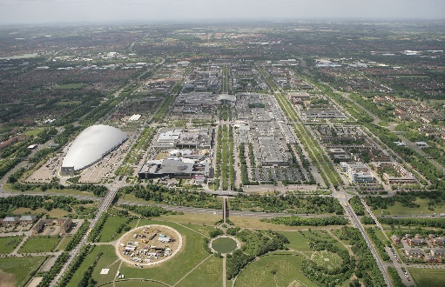

**ABOUT US**

**Welcome to the MK Finance Team**

The finance service is led by Anna Rulton and Natasha Hutchin; both Anna and Natasha started their finance careers in MKC and are now joint Heads of Service and Deputy Section 151 Officers. The finance team take an active lead on all decisions in the council, supporting a number of directors, partners and projects in order to ensure we are giving the best value to our residents and businesses. The finance team includes several functions; business partnering to all areas of the Council, corporate overview including MTFP and Statement of Accounts, procurement, traded services and social care and education transactions. The team is also the client for a number of shared services, including accounts payable, insurance and business systems.

The Professional finance team has recently undertaken a restructure to reflect the changing needs of the service. Having concluded our internal restructuring, we are now excited to launch recruitment for a number of key vacancies within the team. This is a fast-paced area and no day will be the same! We are looking for enthusiastic, inquisitive, and passionate people who will challenge services and processes to ensure good governance and value for money and you will be part of a dynamic, energised finance team who are integral to the wider council services. In return we offer flexible working arrangements, training and development opportunities (we are AAT employer accredited and have a number of the team studying for professional qualifications as well as many making use of our excellent in-house training programmes), including career progression and most importantly the chance to help shape the future of our growing city.

|  |  |
| --- | --- |
|  |  |
| Natasha Hutchin, Head of Finance & Deputy 151 Officer | Anna Rulton, Head of Finance & Deputy Section 151 Officer |

**So, who are we and what do we do?**

**Corporate**

Our Corporate team is the engine room of finance, with responsibilities ranging from producing the Statement of Accounts, managing our capital programme, producing financial & performance information for strategic decision making, ensuring we comply with regulatory requirements to ensuring our partners deliver and that processes and systems perform as they should. Our team offers variety and a real opportunity to broaden your finance experience and knowledge whilst being supportive of each other and working closely in a common interest in delivering on time to a high standard.

**Service Finance Teams**

The finance team work in close collaboration with all services which allows us to get involved with lots of different projects. Every day is different and provides lots of opportunities to work with the services to deliver value for money and improve services to the residents of MK. One day we could be supporting with the re-procurement of our home to school transport or other significant contracts to determine costs, benefits and risks of options, or undertaking service contract monitoring of a range of waste and highways contracts, ensuring we understand cost drivers and external market factors, another day working to increase our pool of foster carers to provide children’s placements, the next supporting with finances to build a brand new school, roads or housing, ensuring schemes are viable, represent VFM and we understand life cycle costs. We also play a key role in developing future budgets based on demand analysis and presenting robust business cases for change.

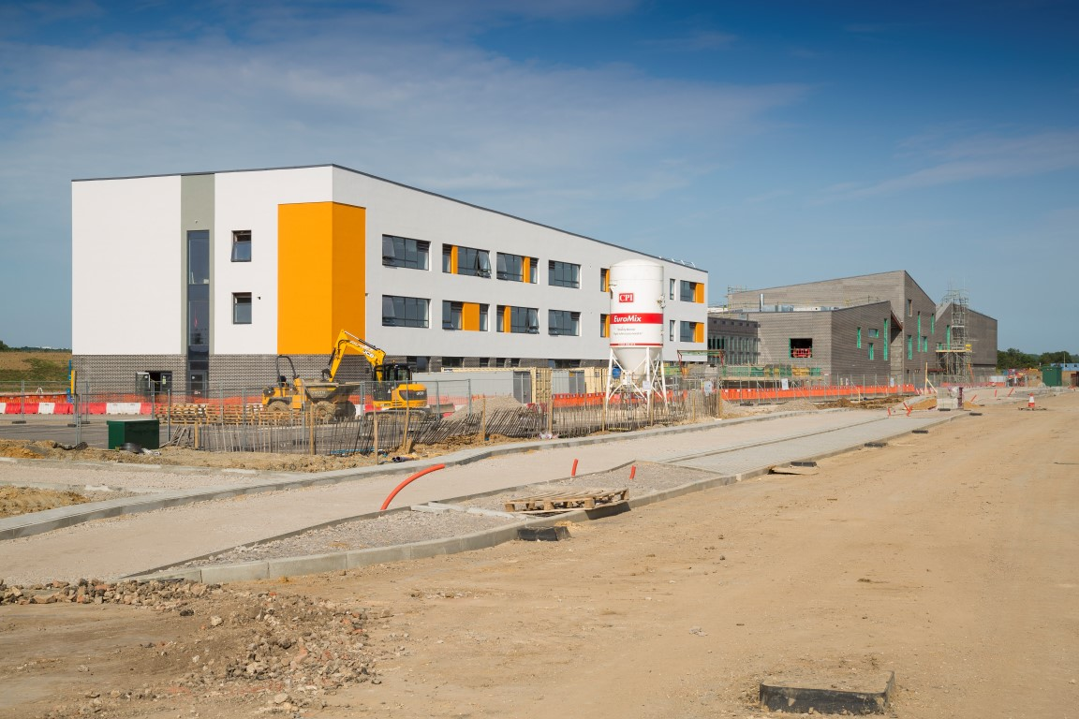

You will have the opportunity to build relationships with colleagues across MKC as well as external colleagues from other local authorities, head teachers, government departments and other external partners.

**Transactions**

We are responsible for processing the payments for all adult social care and early years placements which include residential and nursing care homes, day care, supported living care packages and government funded early years provision. We play an essential role by working closely with various services, ensuring payments are made in line with contractual and funding agreements. We are also responsible for financially assessing adults for social care services for both residential and community care services which means we are providing effective, customer focused, financial support services to vulnerable adults and their carers. We also provide advice and assistance on appropriate welfare benefit advice to maximise the income of service users and the council.

**Read about the experiences of some of our senior management team on working in MKC finance.**

I started my finance career when I first joined MKC as a Graduate Trainee in September 2017. I began studying CIPFA from the beginning and MKC supported me through all 12 exams which I completed in June 2020. As a Graduate I spent time in several different placements within MK Finance, giving me a great opportunity to learn about each one and understand the range of services that MK Council delivers.  I started in the Corporate Finance team and then joined the service finance teams, each supporting their own area of the council’s services including Children’s, Adults, Highways and Transport. I have also been involved in the monitoring of the council’s capital budgets which provided me with a really valuable learning opportunity and gave me an improved awareness of the Council’s overall activities.



*Cristina Pompa, Finance Manager Children’s Services*

Throughout this time, working at MKC has given me the opportunities and exposure to learn and develop in my finance career and my finance colleagues and managers have been supportive and encouraging throughout. I went on to be recruited permanently as an Assistant Finance Business Partner and then a Finance Business Partner.

I will be starting my new role as a Finance Manager supporting the Children’s and Families service at MKC. This includes supporting highly volatile budgets particularly around children’s placements and social work. I find it really interesting to be involved in the service and I regularly join panel and board meetings which allows me to get to the know the area even more. Ultimately, working in finance at MKC has allowed me to collaborate with and support the services to make decisions which has a direct impact on the local community.

**VACANCIES**

**Roles Available**

Milton Keynes Council are looking for both a part time Senior Finance Manager on a fixed term contract within the Corporate and Deputy Executive areas, and a permanent full time Finance Manager to support the Environment & Property Services.

1. Senior Finance Manager – £57,971 to £62,473 FTE( pro rata for 22.2 hours a week)
2. Finance Manager Environment & Property - £45,859 to £50,654

* salaries exclude potential April 2021 pay award

**Senior Finance Manager – 3 days a week**

Senior Finance Manager is a part time 18 month fixed term contract position to cover the financial management of a busy and diverse section of the council. The current full time Senior Finance Manager for this area is being seconded to work on some key one-off projects and so this post will work along-side the existing post holder. The roles of the post will be split in a way that aims to make the arrangement as practical as possible, recognising that there will be some overlap.

The area covers Environment & Waste, Highways, Property, Transport, Planning, Leisure, Law & Governance and Resources services.

More specifically tasks for the role will include:

* Full responsibility for the monthly monitoring reporting from the service areas
* Management of the Finance Team
* Signing off business cases, grant claims and other returns
* Responsibility for the year end reporting of the relevant services and sign off of working papers
* Co-ordination of the budget setting process, including liaison with Directors and Heads of Service

The team consists of 2 Finance Managers, 2 Finance Analysts and an apprentice. The work relates to revenue accounts only and will cover the responsibility for all key finance functions throughout the year – monthly monitoring and reporting, assessment of savings and pressure for budget setting, compliant preparation and execution of year end entries and any ad hoc service or finance projects.

The Job Profile is attached.

The role can either be office based within Central Milton Keynes, or home based with the expectation that at the most, you will be required to work in the office 1 day a week.

We are looking to talk to anyone who is a qualified accountant with experience at working at this level within a public sector environment and with proven leadership skills.

**Finance Manager**

Reporting to the Senior Finance Manager, the Finance Manager will support the Environment and Waste, Highways, Property and Transport areas. These areas are fast moving, complex areas providing services to all citizens in Milton Keynes.

The role will work closely with each of the Heads of Service to understand the operational and consequentially the financial position for the services. The role will be responsible for reporting on a monthly basis to senior management, the expected financial position for each of the services. In addition, there will be a role to play in the budget setting processing, working closely on the preparation and signing off business cases for pressures and savings. The post holder also needs to be technically strong to ensure correct accounting treatment of all entries within the service accounts and completion of year end reporting requirements. The role will manage a Finance Analyst and will be supported by an Apprentice.

More specifically responsibilities will include:

* Undertaking service contract monitoring of a range of waste and highways contracts totalling circa £32m a year, understanding cost drivers and external market factors
* Working with services where these multi million pound contracts are up for renewal to determine the cost of the potential future options and being part of the financial analysis at both the tendering and contract award stage
* Assessing the viability of major one-off capital schemes (£10m plus) including full life cycle costings
* Developing and managing income analysis for operational income in excess of £15m – understanding customer behaviour and the impact on income trends for both current and future budgets
* Offering financial support to our property team who have a significant asset rationalisation programme to ensure assets disposal results in required revenue savings
* Being involved in cost benefit analysis of innovative transport modes, such as vehicle electrification and alternative bus services
* Supporting continual staff restructure workings and monitoring of staffing budgets in excess of £7m.
* Taking a lead on the monthly reporting to senior finance and Cabinet on the overall financial performance of the service area
* Developing future budgets based on demand analysis and presenting robust business cases for change.
* Provision and validation of data for grant returns and freedom of information requests.

The Job Profile is attached.

The role can either be office based within Central Milton Keynes, or home based with the expectation that at the most, you will be required to work in the office 1 day a week.

We are looking to talk to anyone who is a qualified accountant with experience at working at this level within a public sector environment and with proven leadership skills.

In return we offer flexible working arrangements, training and development opportunities (we are AAT employer accredited and have a number of the team studying for professional qualifications as well as many making use of our excellent in-house training programmes), including career progression and most importantly the chance to help shape the future of our growing city. We offer a competitive salary, access to the LGPS, home working with full IT provision, an exciting new finance team and a vibrant and interesting set of services to support.

We look forward to your application. Your application must address all of the essential criteria for the relevant role. Qualification evidence will be required, should you be shortlisted for interview. If applying for more than one role, please ensure you application is tailored to the specific requirements.





**Structure Charts**

*Vacancies are highlighted in green.*

Chart 1 - Corporate & Deputy Chief Executive (Resources, Legal, Environment & Property, Planning)

Chart 2 - Housing, Social Care and Education Finance

* Services covered:

1. Children’s Social Care; Education, Inclusion & Lifelong Learning and Policy, Insight & Communications
2. Adult Social Care; Public Health; Homelessness and Housing Solutions