**ROLE PROFILE**

**Role Title: Public Health Practitioner Workplace Health and**

**Worklessness**

**Service Group: Public Health**

**Accountable to: Public Health Principal Workplace Health and Worklessness**

**Grade: MKC G**

**Date: January 2022**

**JE code: JE1089 Competency Level: 2**

**Purpose of job**

To contribute to the strategic development, planning, implementation and evaluation of specific Public Health programmes and initiatives relating to workplace health, wellbeing and worklessness, to improve health outcomes and reduce health inequalities across Milton Keynes, Bedford Borough and Central Bedfordshire

**Key Objectives**

|  |  |
| --- | --- |
| 1 | To design and manage programmes and projects to improve health and reduce health inequalities particularly in services relating to workplace health, wellbeing and worklessness |
| 2 | To communicate with others to improve health outcomes and reduce health inequalities in the working age population |
| 3 | To work collaboratively across agencies and boundaries to improve health outcomes and reduce health inequalities in the working age population |
| 4 | To work with and through policies and strategies to improve health outcomes and reduce health inequalities, particularly in the area of workplace health, wellbeing and worklessness |
| 5 | To measure, monitor and report population health and wellbeing; health needs, risks and inequalities; and use of services relating to workplace health, wellbeing and worklessness |

**Scope**

The post holder will be expected to work independently and is professionally accountable to the Public Health Principal Workplace Health and Worklessness. They have devolved responsibility for lead areas of work for workplace health, wellbeing and worklessness, including the collation of data and performance management of multiple services.

They will be expected to communicate with and work alongside workplaces across Bedford, Central Bedfordshire and Milton Keynes as well as a range of partner organisations.

The post holder will be responsible for ensuring that projects are delivered within the allocated budget.

**Work Profile**

|  |  |
| --- | --- |
| 1 | Lead the formulation of plans and development of strategies to support workplace health and worklessness |
| 2 | Undertake project management, including the planning, organisation and implementation of relevant public health areas including marketing and communications |
| 3 | Implement policies for workplace health and worklessness and propose service changes to meet the needs of the working aged population and in line with evidence of good practice |
| 4 | To ensure that all projects are delivered within the allocated budget. |
| 5 | To gather evidence to identify priorities for the working aged population to include workplace health needs assessments, health impact assessments. |
| 6 | To understand and interpret data |

**Job Context**

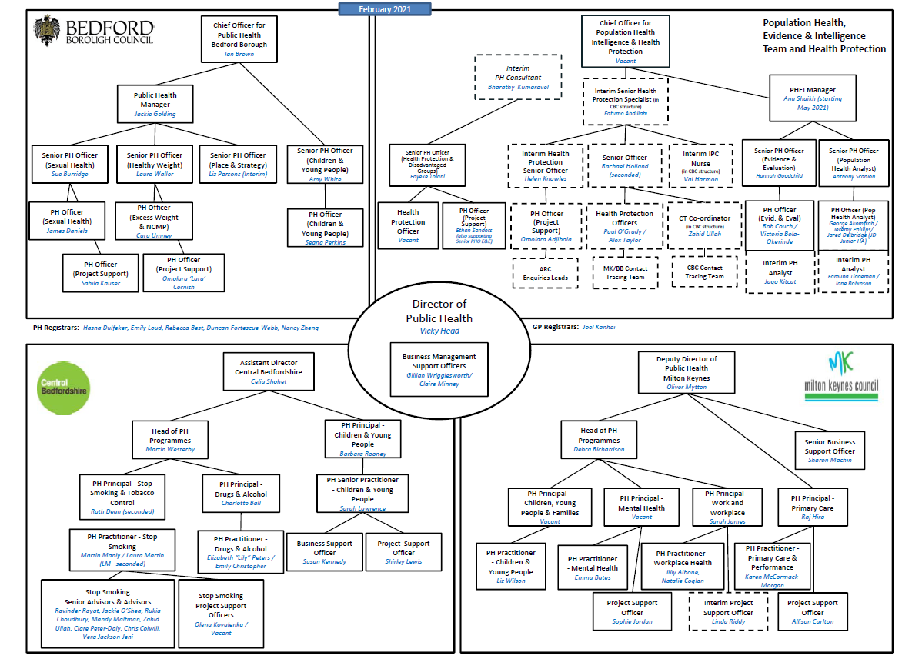

**PERSON SPECIFICATION**

**In this section the Skills, Knowledge, Qualification and Competency requirements to perform the role to a satisfactory standard are set out. The extent, nature and level of the role holder’s knowledge and skills should be specified**

**Awareness** some knowledge or skills sufficient to show aptitude and the ability to learn in the particular work area

**Significant**  knowledge and skills gained through practice and/or qualification sufficient to fulfill the role requirements

**Extensive** knowledge and skills gained through practice and/ or qualification to fulfill the role requirements and contribute to training others and developing policy and practice in the work area

|  |  |  |  |  |  |  |  |
| --- | --- | --- | --- | --- | --- | --- | --- |
| **PERSON SPECIFICATION** | **Examples specific to role** | **Required** | | **Level** | | | **Method of Assessment application form, interview, testing, reference** |
| **Essential** | **Desirable** | **Awareness** | **Significant** | **Extensive** |
| **Knowledge and experience** | Degree-level education and/or relevant professional qualification or equivalent demonstrable experience.  Masters in Public Health  B1.3. develop and / or implement action plans with, and for specific groups and communities, to deliver outcomes identified in strategies and policies  .B1.5. monitor and report on the progress and outcomes of strategy and policy implementation making recommendations for improvement.  C1.2. engage others, build relationships, manage conflict, encourage contribution and sustain commitment to deliver shared objectives  C2.2 communicate sometimes complex information and concepts (including health outcomes, inequalities and life expectancy) to a diversity of audiences using different methods.  A5.5. quality assure and audit services and interventions to control risks and improve their quality and effectiveness  C2.1. manage public perception and convey key messages using a range of media processes.  C2.3. facilitate dialogue with groups and communities to improve health literacy and reduce inequalities using a range of tools and technologies.  C2.4. apply the principles of social marketing, and / or behavioural science, to reach specific groups and communities with enabling information and ideas.  C2.5. consult, and listen to individuals, groups and communities likely to be affected by planned intervention or change. | **√**  **√**  **√**  **√**  **√** | **√**  **√**  **√**  **√**  **√**  **√** |  |  |  |  |
| **Skills, abilities and behaviour** | A4.1. access and appraise evidence gained through systematic methods and through engagement with the wider research community.  A4.2. critique published and unpublished research, synthesise the evidence and draw appropriate conclusions  .B1.1. appraise and advise on global, national or local strategies in relation to the public's health and health inequalities.  B2.1. influence and coordinate other organisations and agencies to increase their engagement with health and wellbeing, ill-health prevention and health inequalities  B3.5 manage and monitor progress and deliverables against outcomes and processes agreed through a contract  .B4.2. operate within the decision making, administrative and reporting processes that support political and democratic systems  .B4.5. work within the legislative framework that underpins public service provision to maximise opportunities to protect and promote health and wellbeing.  B2.5. connect communities, groups and individuals to local resources and services that support their health and wellbeing  .B4.4. help individuals and communities to have more control over decisions that affect them and promote health equity, equality and justice. | **√**  **√**  **√**  **√**  **√**  **√**  **√** | **√**  **√** |  |  |  |  |
| **Managing risk** | Seek independent assurance throughout programme/project planning and processes within organisational governance frameworks. (C3.5) | **√** |  |  |  |  |  |
| **ACCOUNTABILITY and responsibility** | C1.1. act with integrity, consistency and purpose and continue my own personal development | **√** |  |  |  |  |  |
| **Managing resources** | Manage project/programme schedules, resources, budget and scope, accommodating changes within a robust change control process (C3.3) | **√** |  |  |  |  |  |

**COMPETENCIES REQUIRED – All post holders must be able to comply with the Council’s core competency requirements, Customer Focus, Communicating and Engaging, Managing Resources and Risk, Organising and Improving Performance, Taking Responsibility, Team Player, and Excellent Leadership**

**SPOKEN ENGLISH FLUENCY DUTY REQUIREMENT - The ability to converse at ease with members of the public and provide advice in accurate spoken English is essential for this post.**

**CORPORATE SAFEGUARDING STATEMENT – All post holders must be committed to applying and upholding the Council’s Corporate Safeguarding Policy Statement. Specific safeguarding responsibilities should be detailed in this document.**

**Other information**

* able to travel to meet service delivery requirements
* available to undertake work outside of normal working hours

|  |  |  |
| --- | --- | --- |
|  |  |  |
| Signed Line Manager | Signed Service Director |  |
|  |  |  |
| Print Line Manager  Sarah James | Print Service Director | Date |