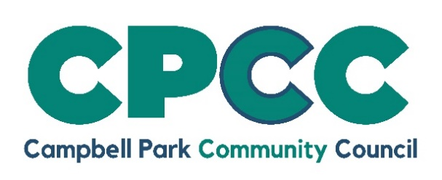
Job Vacancy
Landscape Operative
Salary £25,979-£27,803

An exciting opportunity has arisen within Campbell Park Community Council.
We are looking for an individual who would love the opportunity to help Campbell Park Community Council in the delivery of its high-quality, in-house Landscape service. Someone who enjoys physical, outdoor work, ideally, the individual will have experience of a similar role, and the use of associated machinery (tractors, mowers, strimmers, hedge cutters, chainsaws, pesticide application) Machinery tickets (NPTC/LANTRA) would be an advantage, but not necessary. We also require applicants to have a full, clean driving license. More important than all of this, is the desire to work hard and make a difference to our residents, and be a team player.
The role will involve working across the whole Parish based at the Landscape Depot in Oldbrook. Working hours are 37 per week and the post will be CPPC Grade dependant on experience and qualifications.
You can find a more in-depth description of the job on our website. To request an application pack, please e-mail admin@campbell-park.gov.uk The deadline for the submission of applications, including a covering letter, is noon on 30 September 2024 and should be sent to The Estates Manager, Campbell Park Parish Council, 1 Pencarrow Place, Fishermead, Milton Keynes, MK6 2AS.

