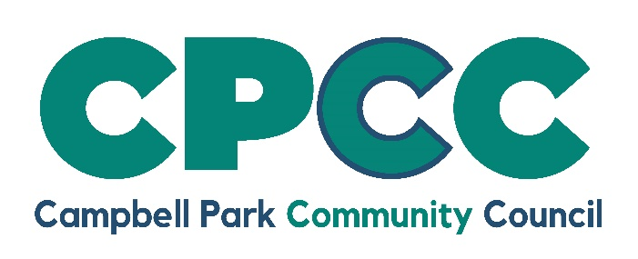

CARETAKER / CLEANER VACANCIES
COMMUNITY CENTRE/COMMUNITY HUB/ALLOTMENTS

16 hours per week £12.85 per hour

Campbell Park Community Council (CPCC) controls and manages community centres in Oldbrook (next to Oldbrook First School) and Springfield (next to the One Stop Shop). Both are open seven days a week, providing facilities used by a variety of community, charity and faith groups. Our new Community Hub on Springfield Boulevard will be opening this year with the potential for being in use 7 days a week. The Community Council also operates two allotment sites in Willen and Woolstone.

The Community Council is currently recruiting part time caretaker / cleaners for the centres, the Hub and the allotment sites and would like to hear from local candidates interested in applying for the posts.

Ideally candidates will have experience in a similar post, as well as a flexible approach to duties, location and hours of work.

Good communication and customer service skills are essential.

Successful candidates will be required to undertake a DBS check.

Potential candidates for the posts, should visit www.campbell-park.gov.uk, e-mail admin@campbell-park.gov.uk or call 01908 608 559 to request an application pack.

CPCC is an equal opportunities employer

