#### ROLE PROFILE

**Role Title: Senior Transport Planner (Scheme Development)**

**Service Area: Transport Services**

**Directorate: Place**

**Accountable to: Strategic Lead – Transport Planning and Policy**

**Grade: G**

**JE Code: JE1780 Competency Level: 2**

**Purpose of job** (outline what, to whom and why)

To formulate, implement and monitor transport strategies, policies, programmes, plans and other documents at a local, regional and national level for the council. To identify, develop, secure funding for and support delivery of a pipeline of transport schemes that will lead to the successful delivery of the council’s transport plans.

**Key Objectives** (list what outcomes are essential)

|  |  |
| --- | --- |
| 1 | To manage the identification and prioritisation of transport schemes to support the council’s transport plans, including public transport schemes, walking and cycling schemes, highways schemes and technological initiatives. |
| 2 | To provide professional advice relating to transport policy, and lead on work to research, write and adopt new transport policies and strategies. |
| 3 | To manage the preparation of business cases to support scheme development and delivery. |
| 4 | To manage the development of transport schemes in line with defined priorities, ensuring that a portfolio of shovel-ready schemes are in place to exploit funding opportunities as they arise. |
| 5 | To proactively identify funding opportunities that will help secure investment into transport infrastructure in Milton Keynes. |
| 6 | To work closely in partnership with businesses, developers, transport operators and other stakeholders to support the development and delivery of transport policy and schemes in line with the council’s objectives |
| 7 | Work with the Strategic Lead Transport Policy and Planning to ensure resources are in place to successfully develop a portfolio of schemes and report progress to the relevant programme board. |
| 8 | To report on the development and delivery of projects and programmes as necessary through agreed governance arrangements in line with the council procedures. |

**Scope** (outline the size or scope of the role, direct or indirect responsibility for people, finances, resources and any special aspects of the role)

This role is a key position within the Transport Policy and Planning Team supporting the delivery of the transport policy and planning function with a focus on identifying and developing transport schemes and initiatives that will help to support the successful delivery of the council’s transport plans.

The post holder will lead on areas of new transport policy development requiring research, option development, engagement and report writing skills to take new policies and strategies through to adoption by the council. Crucially, the post holder will be responsible for the identification, development and prioritisation of outline business cases for a pipeline of schemes across the whole transport service that can either be funded from existing funding streams or used to secure funding as opportunities arise, for example through competitive bids to government or developer contributions.

The post holder will also build relationships with external stakeholders to help ensure that schemes and policies they are proposing help support the council’s objectives

The role demands frequent formal and informal liaison with internal officers, partner organisations and stakeholders to develop forward looking, long term initiatives that will see a shift towards more sustainable modes of transport as the future planned growth of the city is delivered.

It is important to note that this is a planning role rather than an engineering role, and while a basic knowledge of transport engineering principles is desirable the purpose of the role is primarily to develop schemes in outline form in order for more detailed development and delivery by Technical Leads and the council’s Highways Service once funding has been secured.

**Work Profile** (outline the main areas of responsibility and accountability and competencies)

1. To provide transport policy expertise and lead on the research, development and agreement of new transport policies and strategies.
2. Support the Strategic Lead – Transport Planning and Policy in the identification, development and prioritisation of walking and cycling schemes that will help encourage greater use of active travel modes in line with the council’s objectives
3. Support the Strategic Lead – Passenger Transport in the development of an ongoing programme of passenger transport infrastructure improvements across the city in order to achieve key targets for passenger growth, including priority measures, waiting facilities and information and ticketing initiatives.
4. Support the Strategic Lead – Parking and Taxis in the identification, development and prioritisation of car parking initiatives that will help encourage better utilisation of the council’s car parking stock across Milton Keynes in line with the council’s objectives
5. Assess outputs from the council’s Multi-modal Transport Model to identify and prioritise highways interventions that will be required to accommodate future growth
6. Work with the council’s Head of Transport Innovation to identify and prioritise opportunities for delivering technological interventions that support the delivery of the council’s transport plans.
7. Develop effective, strong partnerships with transport operators, businesses, developers and other stakeholders to ensure that shared objectives are in place that help secure the delivery of effective transport services and infrastructure schemes
8. To proactively identify funding opportunities from other sources that will help secure investment into transport infrastructure in Milton Keynes, and to manage the preparation of business cases to secure funding for delivering interventions
9. To engage with developers and internal colleagues within development control to secure contributions towards schemes that help deliver the council’s transport plans.
10. Liaise with elected councillors, adjoining authorities, transport service providers and relevant transport user groups.
11. Prepare and present reports to committees, panels etc as appropriate and provide advice and support and take any consequential action necessary.
12. To appoint and manage transport consultants from the council’s term frameworks to support the development of initiatives, schemes and funding bids as necessary

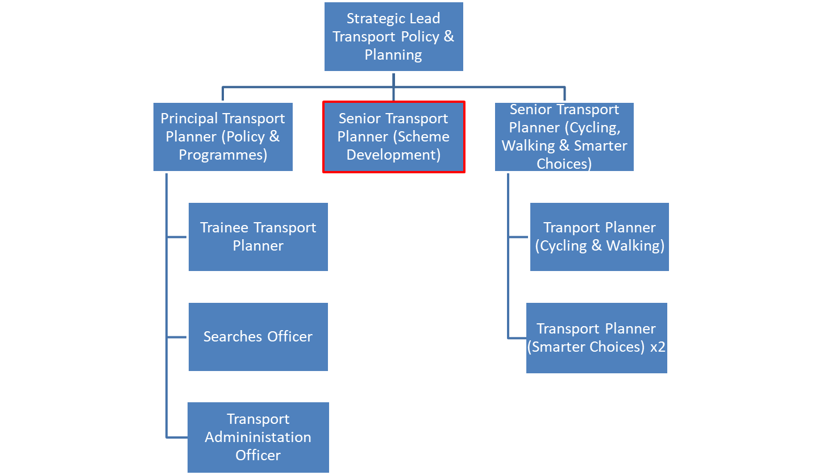**PERSON SPECIFICATION**

**In this section the Skills, Knowledge, Qualification and Competency requirements to perform the role to a satisfactory standard are set out. The extent, nature and level of the role holder’s knowledge and skills should be specified**

**Awareness** some knowledge or skills sufficient to show aptitude and the ability to learn in the particular work area

**Significant**  knowledge and skills gained through practice and/or qualification sufficient to fulfil the role requirements

**Extensive** knowledge and skills gained through practice and/ or qualification to fulfil the role requirements and contribute to training others and developing policy and practice in the work area

|  |  |  |  |  |  |  |  |
| --- | --- | --- | --- | --- | --- | --- | --- |
| **PERSON SPECIFICATION** | **Examples specific to role** | **Required** | | **Level** | | | **Method of Assessment e.g. application, interview, testing, reference** |
| **Essential** | **Desirable** | **Awareness** | **Significant** | **Extensive** |
| **SKILLS AND KNOWLEDGE**  **Technical knowledge and qualifications** | Knowledge of traffic and transportation issues relating to passenger transport, active travel, highways, parking and taxis  Ability to manage, supervise and coordinate output from internal staff and external consultants.  Knowledge of and ability to apply project management techniques.  Ability to write reports on complex strategic issues and the ability to present them to a range of audiences, from the general public to fellow transport practitioners.  Proficient IT skills in the use of Word, Excel, Project, and PowerPoint.  Understanding of planning and development control procedures and requirements, as they relate to seeking contributions, either physical or monetary, towards improving the passenger transport offer.  Research skills and an ability to remain up to date with current transport legislation, advice and initiatives.  Knowledge of Local Authority governance arrangements and procedures.  Understanding of “political” dimensions and issues surrounding development.  Ability to interpret outputs from transport models  Knowledge of Planning guidance.  Degree or equivalent in a related subject  Eligible to be a full member of a relevant professional body (e.g. CILT, ICE, IHT)  Post Graduate qualification (or similar) in a related field.  Knowledge of scheme prioritisation methods, including DfT Webtag | **Y**  **Y**  **Y**  **Y**  **Y**  **Y**  **Y**  **Y**  **Y**  **Y** Y | **Y**  **Y**  **Y**  **Y** |  | **Y**  **Y**  **Y**  **Y**  **Y**  **Y**  **Y**  **Y** | **Y**  **Y**  **Y**  **Y** | **INTERVIEW / APP**  **INTERVIEW /APP**  **INTERVIEW / APP**  **INTERVIEW /APP**  **APP**  **INTERVIEW / APP**  **INTERVIEW / APP**  **INTERVIEW / APP**  **INTERVIEW /APP**  **INTERVIEW / APP**  **INTERVIEW / APP**  **APP**  **APP**  **APP**  **INTERVIEW / APP** |
| **Planning and organising work** | Ability to prioritise and programme tasks in order to deliver outcomes to tight deadlines.  Methodical and well organised with the ability to produce quality work. | **Y**  **Y** |  |  |  | YY | **INTERVIEW / APP**  **INTERVIEW / APP** |
| **Planning capacity and resources** | Ability to assess relative priorities and allocate appropriate resources to ensure deadlines is met.  Ability to procure and oversee consultancy support | **Y**  **Y** |  |  | **Y** | **Y** | INTERVIEW / APPINTERVIEW / APP |
| **Influencing and interpersonal skills** | Ability to build strong partnerships with a range of partners and external stakeholders.  Ability to communicate ideas and strategies to a range of audiences.  Ability to apply a range of negotiation and persuasion skills to suit differing circumstances.  Ability to represent the Department at meetings (internal, external and with Members) sometimes requiring attendance out of normal working hours. | Y **Y**  **Y**  **Y** |  |  | **Y**  **Y**  **Y** | **Y** | INTERVIEW / APP **INTERVIEW / APP**  **INTERVIEW / APP**  **INTERVIEW / APP** |
| **PROBLEM-SOLVING**  **Using initiative to overcome problems** | Ability to interpret complex, and sometimes conflicting data, in order to develop suitable infrastructure schemes that support their delivery or the council’s transport plans.  Ability to analyse situations and identify and communicate problems to the Team Leaders, suggesting a range of possible solutions. | **Y**  **Y** |  |  |  | **Y**  **Y** | INTERVIEW / APPINTERVIEW / APP |
| **Managing risk** | Ability to undertake risk assessments of transport infrastructure proposals and to identify and communicate mitigation measures to colleagues, partners and stakeholders. | Y |  |  | Y |  | **INTERVIEW / APP** |
| **Managing change** | Ability to assess and monitor internal processes and suggest changes in order to deliver continuous improvement. | Y |  |  | Y |  | **INTERVIEW / APP** |
| **ACCOUNTABILITY and RESPONSIBILITY**  **Undertakes tasks without supervision** | Ability to work autonomously, manage projects with minimum supervision, whilst delivering to tight deadlines | Y |  |  |  | Y | **INTERVIEW / APP** |
| **Managing people** | Ability to provide leadership, manage and co-ordinate the work of colleagues not under direct line management supervision.  Ability to effectively manage consultants to secure effective outputs | Y **Y** |  |  |  | Y **Y** | **INTERVIEW / APP**  **INTERVIEW / APP** |
| **Managing financial resources** | Budget monitoring and control skills. | Y |  |  | **Y** |  | **INTERVIEW / APP** |

**COMPETENCIES REQUIRED – All post holders must be able to comply with the council’s core competency requirements which include communication, respect for others, customer service, drive for results, delivering the promise and continuous personal development.**

**SPOKEN ENGLISH FLUENCY DUTY REQUIREMENT - The ability to converse at ease with members of the public and provide advice in accurate spoken English is essential for this post.**

**In addition for those posts with management responsibilities the competencies will include managing self and personal skills, providing direction, facilitating and managing change, working with people, using resources, achieving results, promoting policy, values and culture, customer service and health and safety.**

**Other information**

* able to travel to meet service delivery requirements
* available to undertake work outside of normal working hours

|  |  |  |  |
| --- | --- | --- | --- |
|  |  |  |  |
| Signed Job holder | Signed Line Manager | Signed Assistant Director |
|  |  |  |
| Print Job holder | Print Line Manager | Print Assistant Director | Date |