**ROLE PROFILE**

|  |  |  |  |
| --- | --- | --- | --- |
| **Job Title** | **SOCIAL WORKER – level 2** | | |
|  |  | | |
| **Directorate** | **Community Wellbeing** | | |
| **Section** | **Adult Social Care and Health** | | |
| **Accountable to** | **Team Manager/ Senior Practitioner** | | |
| **Grade G** |  | | |
| **June 2014**  **JE1174** |  |  |  |

|  |
| --- |
|  |

**Purpose of Role**

With support and guidance from more experienced colleagues to carry out the duties of a professional Social Worker within Adult Social Care. To assess the needs of adults and determine if they meet the Milton Keynes eligibility criteria for receiving social care. To assess the needs of their families and informal carers. To analyse information and ensure timely and effective interventions to meet eligible needs. To make sure that support plans are developed and implemented that ensures the adult’s safety, well being and independence in order to lead a fulfilled life. This is to be completed in accordance to the terms and guidance of the relevant legislation and professional code of practice.

**Key Objectives** (list what outcomes are essential)

|  |  |
| --- | --- |
| 1. | Assessments are carried out effectively, and within timescales so that support needs are clearly identified and recorded |
| 2 | Devise and implement clear support plans and interventions appropriate for each person to address identified needs. |
| 3 | Manage a case load under the supervision/guidance of the Team Manager/Senior Practitioner. |
| 4 | Accurate individual case records are maintained electronically and reports are provided as required. |
| 5 | Attend regular supervisory meetings with team manager and/or a senior member regularly to monitor progress and identify development needs |
| 6 | Works closely with other agencies and services in a co-operative way, sharing information and planning care together to meet the needs of the service users holistically. |
| 7 | Undertakes Safeguarding investigations and forms safeguarding plans to protect adults at risk. |

______________________________________________________________

**Scope**

This role is the second level in the career grade for professionally qualified Social Workers. At this level, the Social Worker is operating in their full professional role, but still requires significant supervisory support and help with more complex cases. Having gained experience in case work with vulnerable adults, the role works more independently than at the first level and has a greater ability to translate knowledge gained from their study into their day to day work. In effect, the post is effectively “inducted” into the organisation and in to operational Social Work. However, as a still relatively inexperienced professional, the post requires input from more experienced colleagues for more complex cases.

The role requires regular liaison with colleagues in the directorate, across the Council and in partner agencies.

The role of a social worker is a challenging one, requiring a range of complex skills and a sound knowledge base from which to practice. Of paramount importance are the skills and knowledge required to carry out high quality assessments and implement effective interventions with vulnerable adults. Social workers must possess an understanding adult social care legislation and guidance framing their work and have the ability to form positive relationships with service users and carers and other professionals and possess strong report writing and oral skills. Social workers need to be confident, articulate, professional and possess emotional resilience and determination.

This is a crucial responsive front line role demanding a good level of critical thinking and creativity, and the need to work at a fast pace. Directly responsible for supporting vulnerable adults and carers, taking timely action to ensure support needs are met and adults at risk are safeguarded.

The role works in a difficult and often challenging area. Therefore, the role holder may be exposed to unhygienic environments and may face aggression or challenges. The role holder is responsible for confidentiality and the security of data and for equipment issued to them i.e. lap tops, tablets and mobile telephones.

**Work Profile**

The social worker will carry out the Council’s duties in respect adult social care legislation, using their professional skills to carry out person centred assessments, in line with the assessment framework, and develop, implement, monitor and review effective support plans and interventions to minimise risk, enhance the wellbeing of service users.

This occurs within a framework of line management and professional supervision. This is a high risk area of work, where assessment, analysis and judgement, the skills of building trust and credibility and of listening to vulnerable adults are all critical to ensuring good outcomes. The social worker will work in an authoritative and systemic way with service users and carers and key services to improve outcomes for vulnerable adults.

Conducts assessments and monitors and reviews support plans in line with statutory time scales. Recording fully the designated recording system.

Supporting colleagues in other teams when pressures of work require.

Keeping up to date with policy and legislation and developments in professional practice. Using reflection and other techniques and development tools to continually improve professional practice.

The role holder has professional responsibility for his/her own personal development and for contributing to team and service development. Role holder is ambassador for the Council and must exercise high standard of customer care.

The role holder will work alongside other agencies and services to ensure excellent outcomes for service users and carers.

The role holder is expected to participate in staff meetings and to contribute to the development of the team.

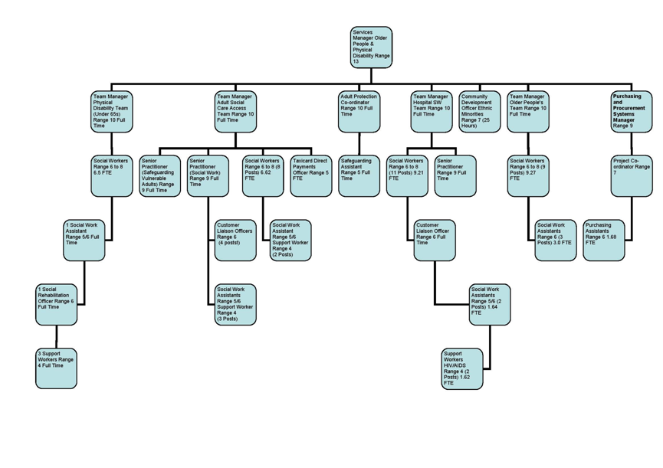

**PERSON SPECIFICATION**

**In this section the Skills, Knowledge, Qualification and Competency requirements to perform the role to a satisfactory standard are set out. The extent, nature and level of the role holder’s knowledge and skills should be specified**

**Awareness** some knowledge or skills sufficient to show aptitude and the ability to learn in the particular work area

**Significant**  knowledge and skills gained through practice and/or qualification sufficient to fulfil the role requirements

**Extensive** knowledge and skills gained through practice and/ or qualification to fulfil the role requirements and contribute to training others and developing policy and practice in the work area

|  |  |  |  |  |  |  |  |
| --- | --- | --- | --- | --- | --- | --- | --- |
| **PERSON SPECIFICATION** | **Examples specific to role** | **Required** | | **Level** | | | **Method of Assessment interview, testing, reference** |
| **Essential** | **Desirable** | **Awareness** | **Significant** | **Extensive** |
| **SKILLS AND KNOWLEDGE**  **Technical knowledge and qualifications** | Social work qualification (DipSW, CQSW, Degree in social work or equivalent)  Registered as a Social Worker  Knowledge of main issues in relation to own client group  Awareness of the legislative framework within which the role operates  Proven ability to relate professionally with vulnerable adults, carers and their families evidenced through previous work as a Social Worker  Able to undertake a range of statutory assessments and formulate support plans | X  X  X  X  X  X |  |  |  |  | **Application form**  **Interview and test** |
| **Planning and organising work** | Ability to analyse, summarise and write/ record relevant information clearly and concisely so that it is easily understood by users and colleagues  Able to communicate clearly with clients and with other colleagues, and effectively in writing  Able to prioritise work effectively based on need and risk  Ability to use IT systems effectively to record | X  X  X |  |  | **X**  **X**  **X**  **X** |  | **Verbal Reasoning Test**  **interview** |
| **Planning capacity and resources** | Able to manage own work load effectively  Flexible and willing to support other staff when need arises. | X  X |  |  | X  X |  | **Interview and test** |
| **Influencing and interpersonal skills** | Ability to work as part of a team including working co-operatively with other professionals and agencies to meet the needs of service users | X |  |  | X |  | **interview** |
| **PROBLEM-SOLVING**  **Using initiative to overcome problems** | Skills and knowledge in listening to service users and in carrying out complex outcome focused assessments. Able to collect, analyse and make judgements about complex information  Able to develop, implement and monitor support plans  Able to be person centred and treat all with respect and with empathy  Ability to question, challenge, solve problems and complete tasks | X  X  X  X  X |  |  | X  X  X  X  X |  | **interview** |
| **Managing risk** | Able in consultation with manager, to make considered decisions, analyse and evaluate information in high risk situations and safeguard vulnerable adults | X |  |  | X |  | **Interview and test** |
| **Managing change** | Flexible and able and willing to adapt to change | X |  |  | X |  | **Interview** |
| **ACCOUNTABILITY and RESPONSIBILITY**  **Undertakes tasks without supervision** | Ability to maintain up to date records  Ability to share any perceived difficulties with Supervisor openly  Takes responsibility for quality and completion of own work to MKC standards | X  X  X |  |  | X  X  X |  | **interview** |
| **Managing people** | Joint work with more experienced staff direct and support and supervise unqualified support workers and social work assistants | X |  |  | X |  |  |
| **Managing financial resources** | Able to manage own time and find cost effective solutions to meet needs.  Be responsible for commissioning cost effective solutions to meet identified needs seeking appropriate authorisation for all commitments | X |  |  | X |  | **interview** |

**COMPETENCIES REQUIRED – All post holders must be able to comply with the Council’s core competency requirements which include communication, respect for others, customer service, drive for results, delivering the promise and continuous personal development.**

**In addition for those posts with management responsibilities the competencies will include managing self and personal skills, providing direction, facilitating and managing change, working with people, using resources, achieving results, promoting policy, values and culture, customer service and health and safety.**

**SPOKEN ENGLISH FLUENCY DUTY REQUIREMENT - The ability to converse at ease with members of the public and provide advice in accurate spoken English is essential for this post.**

**Other information**

* able to travel to meet service delivery requirements
* available to undertake work outside of normal working hours

|  |  |  |  |
| --- | --- | --- | --- |
|  |  |  |  |
| Signed Job holder | Signed Line Manager | Signed Assistant Director |  |
|  |  |  |  |
| Print Job holder | Print Line Manager | Print Assistant Director | Date |